ERP = Enterprise Resource Planning

Core ERP :

1. **Administrative** portfolio {Accounting – Finance – HR – Project management -Tax payment}
2. **Operational** portfolio {MRP – CIM} (CRM is in extended ERP)
3. **Executive** portfolio



Extended ERP :

1. CRM (Customer Relationship Management)
2. PLM (Product Life cycle Management)
3. CSM (Supply Chain Management)

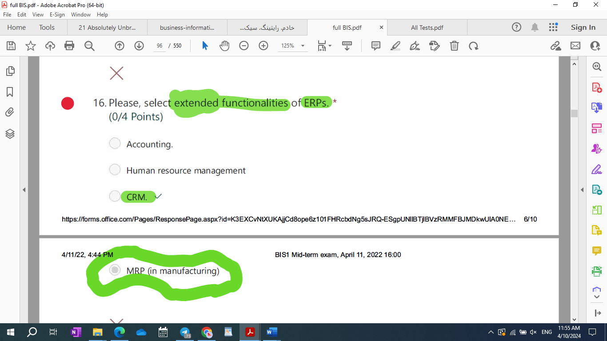

ERP paradigms :

1. Information integration
2. Extension and modularity
3. Process prescriptiveness.

KPIs = Key Performance Indicators

ABC = Activity Based costing

CRM = Customer Relationship Management

1. Operational
2. Analytics
3. Executive

BPR = Business Process Reengineering -> With BPR, knowledge workers become generalists

PLM = Product Lifecycle Management

SCM = Supply Chain Management

OEE = Overall Equipment Effectiveness

1. The lower the efficiency/availability, the lower the OEE.
2. The higher the downtime, the lower the OEE.

Companies that can manage their business process by software like 1C:Drive:

1. Service companies
2. Distribution companies
3. Pro duction companies
4. Small manufacturing companies
5. A company doing import and export

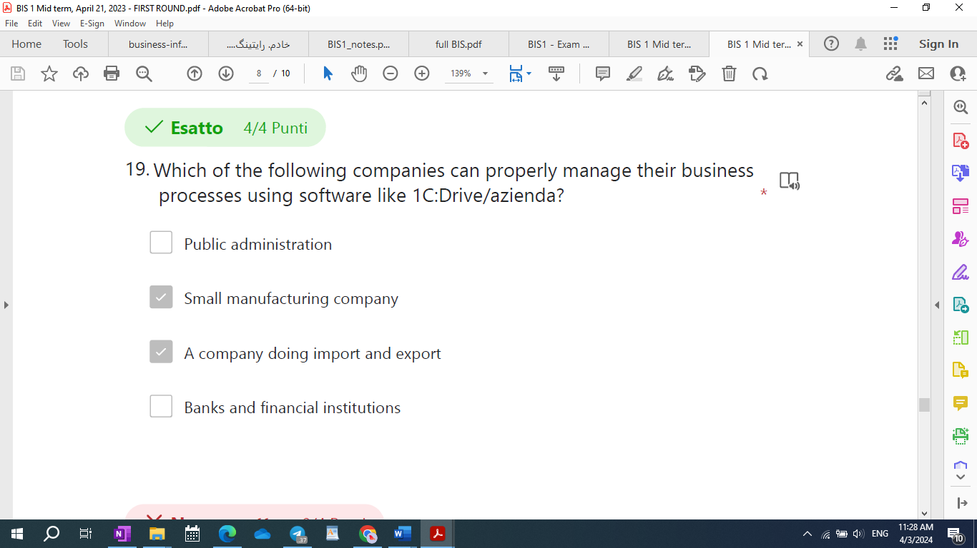

1. Bankes
2. Public administration
3. School
4. Social media companies
5. Financial in

SFA = Sale Force Automation

Typical objectives of SFA

1. Reduce the cost of customer acquisition.
2. Decrease customer churn.
3. Reduce bureaucracy for customers and increase responsiveness during the sales process.
4. Increase effectiveness of the sales force.

What are typical objectives of sales force automation (SFA)?

* 1. Reduce the costs of customer acquisition.
  2. Decrease customer churn.
  3. Reduce bureacracy for customers and increase responsiveness during the sales process.
  4. Increase the effectiveness of the sales force.

|  |  |
| --- | --- |
| Reduce | Increase |
| 1. Bureaucracy 2. cost of customer acquisition 3. customer churn 4. risk associated with changing job or retire | 1. responsiveness during the sale process 2. effectiveness of the sale force 3. customer retention |

Sell in / Sall out Data

Sell in related to the sales from **producer** to **distributor** (Directly)

Sell out related to the sales from **distributor** to **final consumer** (Indirectly)

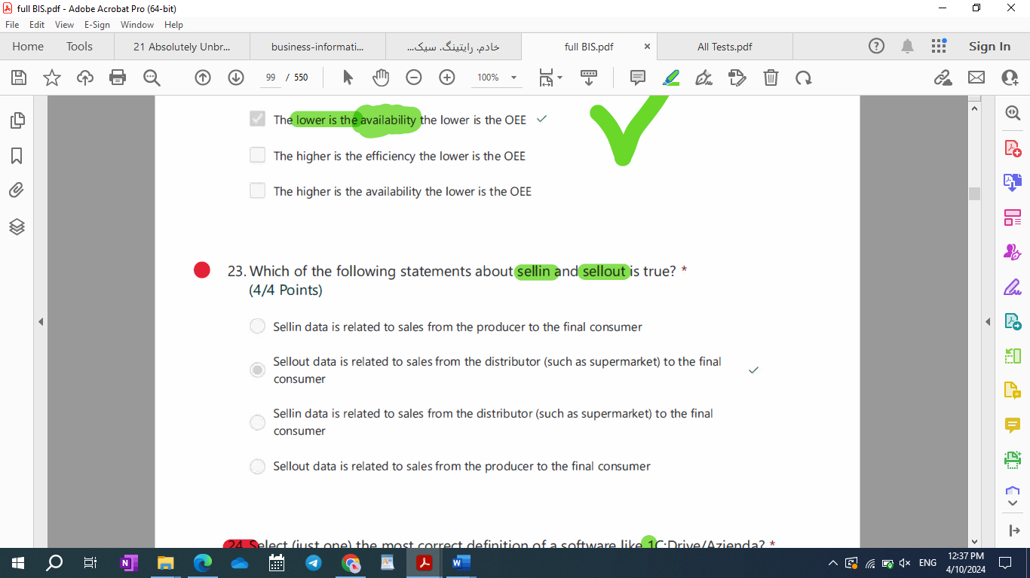

Which of the following statements about sellin and sellout is true?

1. Sellin data is related to sales from the producer to the final consumer
2. Sellout data is related to sales from the distributor (such as supermarket) to the final consumer
3. Sellin data is related to sales from the distributor (such as supermarket)to the final consumer
4. Sellout data is related to sales from the producer to the final consumer

Which of the following statements about sellin and sellout is true?

1. Sellin data is related to sales from the producer to the final consumer
2. Sellout data is related to sales from the producer to the final consumer
3. Sellout data is related to sales from the producer to the distributor (such as supermarket).
4. Sellin data is related to sales from the producer to the distributor (such as supermarket).

CIM = Computer integrated Manufacturing

MRP = Material Requirement Planning

CSF = Critical Success Factor

SAP = Systems, Application, and Products -> – Cloud based ERP interface

SAP HANA – in memory databases

1C:Drive/Azienda program

Main modules are: CRM – Sale – Product – Quality – Payroll – purchase – service – accounting -warehouse

DB = Databases

EDWH = Enterprise Data warehouse

15-R-M: Repeated Which of the following is a true statement about EDWH (Enterprise Datawarehouse)?

1. The structure of an EDWH is typically set on **one level**, the datamart.
2. The staging layer is where data are imported at first, in **both** staging and datamart layer the structure definition is driven by source structures
3. The structure of an EDWH is typically set to more levels, with a partial replication of the information between one level and the next.
4. The staging layer is where data are imported at first, in the datamart layer the structure definition is driven by analysis requirements.

|  |
| --- |
| The structure of a data warehouse is typically set to more levels, with a partial replication of the information between one level and the next. Which is typical one?   1. First level or Staging Area; Second Level or Data Mart 2. First level or Staging Area; Second Level or Reporting Layer 3. First level or Staging Area; Second Level or Data Mart; Third Level or Data Warehouse 4. First level or Staging Area; Second Level or Data Warehouse; Third Level or Data Mart |

R-0: What is the difference between the datamart and the staging layer in an EDWH (Enterprise Datawarehouse)?

* 1. The staging layer is where data are imported at first, its structure definition is driven by the source system . In the Datamart the structure definition is driven by analysis requirements.
  2. The staging layer is where data are imported at first, in **both** staging and datamart layer the structure definition is driven by the source system.
  3. The staging layer a fisrt data integration is performed as test,then data are imported from the source system into the datamarts directly is where data are imported at first, in **both** staging and datamart layer the structure definition is driven by the source system
  4. The staging layer is where data are imported at first, in **both** staging and datamart layer the structure definition is driven by analysis requirements.

ELT = Extract, transform, and Load

|  |  |  |  |  |  |  |  |  |  |  |  |  |
| --- | --- | --- | --- | --- | --- | --- | --- | --- | --- | --- | --- | --- |
| Technology = is a process and the sources needed to perform this process  Or  what a company capable of performing/doing  Technical system = a set of machines supporting a given technology  Information system = a subset of the technology of a company  Or  a set of information process that a given company can perform  IT architecture = a technical system supporting a given information system   |  |  |  | | --- | --- | --- | |  | Technology |  | | Technical system |  | Information system | |  | IT Architecture |  | |  | Technical innovations |  | |

|  |
| --- |
| List of Modules (SAP)  - SD Sales and Distribution (Ciclo Attivo)  - MM Materials Management  - PP Production Planning  - QM Quality Management  - PM Plant Managenent (manutenzione)  - HR Human Resource  - FI Finance  - CO Controlling  - AM Asset Management  - PS Project (gestione progetti)  - WF Workflow  - IS Information System (Sistema Statistico) |

* Important: 6-R-M: Which of these options represent a benefit of an OnCloud solution?

1. the old architecture can be simply switched off;
2. the IT skills required are the same as an on prem architecture;
3. lower cost with same performance as an on prem architecture;
4. more flexible scalability compare to an on prem architecture;

It seems that the option 4 is the only option, we can choose.

* Important: 9-R-M: Why is price the information system of markets?

1. Because market coordination is based on the execution of economic transactions, which in‐ volve a payment of a price.
2. Because through competition (in perfect market conditions), average market price is a reliable indication of the value that the client can obtain from the transaction.
3. Because price carries information on the quantity of products and is a driver of purchasing decisions.
4. Because price carries information on the quality of products and, in a perfect market system, is the driver of purchasing decisions.

14-R-M: What are correct statements on the dimension(s) of indicators in executive information systems?

1. Typical dimensions are time, customers and products.
2. Dimensions represent the units of measurement of KPIs.
3. Dimensions represent columns in the DWH tables
4. The value of an indicator is defined given a vector of values of relevant dimensions.

* 15- R-0: In a company with three BW environment (development and production), what is the purpose of the **development environment**?

1. Test the developments
2. There is always a unique environment, the production environment
3. Be able to make new developments with no impacts on the production environment
4. There is always a unique environment, the development environment

|  |  |
| --- | --- |
| purpose of the **development environment** | purpose of the **production environment** |
| **Make new developments** **no impact** **on production environment** | Final users **have access and can see data** with **no development ongoing** |

* 18-R-M: Please, tick statement(s) that correctly apply to **Activity Based Costing** (ABC) .

1. According to ABC, operations are associated with costs
2. According to ABC, operations can be associated with an internal pricing system
3. ABC enables the assessment of progress from an operational management perspective (time, production rate, use of production plants/machines)
4. With ABC, progress of operational activities can be reconciled with administrative cash flows

* 18-R-M: Please, tick statement(s) that correctly apply to Activity Based Costing (ABC) .

1. According to ABC, operations are associated with costs
2. According to ABC, operations can be associated with an internal pricing system
3. ABC enables the assessment of progress from an ~~operational management perspective~~ (time, production rate, use of production plants/machines)
4. With ABC, progress of operational activities can be reconciled with administrative cash flows – (can be not cant be)



* 19-R-M: Why doesn’t non-IT technical innovation have an impact on scope economies?

1. Because scope economies are not related to innovation.
2. Because scope economies are inherently different from scale economies and do not originate from greater efficiency of production processes.
3. Because increasing scope economies requires better coordination and non-IT technologies do not support coordination.
4. Because non-IT technical innovation increases organizational **effectiveness** only.



|  |  |  |
| --- | --- | --- |
|  | CRM Modules |  |
| Operational | Analytical | Executive |
| 1. Sale force 2. Call center 3. Mobile 4. Agencies and shops 5. Mail | 1. Customer profiling 2. Discovering insight from customers data which are useful for business management. 3. Identification of new KPIs 4. Visualization tools | Selection and definition of customer KPIs  Definition of service and objective |

* 23-R-M: What are module(s) of operational CRM? *

1. Sales force
2. Mail
3. Call center
4. Agencies and shops

12

How can companies deal with environmental uncertainty according across decision theory?

1. They increase their information processing capacities (the capacities that go beyond the limits of

individual rationality) by implementing:

a. vertical information system.

b. horizontal information system.

2. Increase slack resources. Build up some reserve that it’s possible to use when it’s needed to insert flexibility. E.g. if you’re really fast with 3. processes and cycles, you don’t need to have a lot of resources in your warehouse, because you’re very quick at adapting at a changing according to the changes of the market demand.

So, it’s possible add slack resources by implementing:

a. a warehouse.

b. Create independent organizational units according to the divide et impera paradigm.

1. Please, tick consolidated belief(s) tieing technical innovation with organizational change for non-IT technologies.  
   1- There is no relationship between technical innovation and **scale** economies.  
   2- Technical innovation increases organizational efficiency.  
   3- Technical innovation increases the general complexity of managing a company.  
   4- Technical innovation increases the level individual specialization.

* 5-R-M: Please, tick consolidated belief(s) tieing technical innovation with organizational change for non-IT technologies.

1. Technical innovation increases the level individual specialization.
2. Technical innovation increases organizational efficiency and **effectiveness**.
3. Technical innovation increases the general complexity of managing a company
4. There is no relationship between technical innovation and **scope** economies.

* 1-R-M: Please, tick consolidated belief(s) tieing technical innovation with organizational change for non-IT technologies.

1. Technical innovation increases the general complexity of managing a company.
2. Technical innovation increases organizational efficiency and effectiveness.
3. **There is no relationship between technical innovation and scope economies.**
4. Technical innovation increases the level individual specialization.

* 19-R-M: Why doesn’t non-IT technical innovation have an impact on scope economies?

1. Because **scope** economies are **not** related to innovation.
2. Because scope economies are inherently different from scale economies and do not originate from greater efficiency of production processes.
3. Because increasing scope economies requires better coordination and non-IT technologies do not support coordination.
4. Because non-IT technical innovation increases organizational **effectiveness** only.

Please, tick consolidated belief(s) tieing technical innovation with organizational change for non IT technologies. *

1. Technical innovation increases organizational efficiency and **effectiveness**.
2. Technical innovation enables scale economies.
3. Technical innovation increases individual specialization.
4. Technical innovation increases bureaucracy, but does not affect the formalization of work.

* 2-R-M: What are phase(s) of the CSF method?

1. Interview with knowledge workers
2. Robustness analysis: aimed at selecting KPIs
3. Refinement and documentation: presentation to customer, possible modifications, specification (written, but informal)
4. Predefinition: desk analysis

|  |
| --- |
| *CSF method - steps*  CSF method requires 4 phases:  • **Predefinition**: desk analysis  • **Interview**: aimed at identifying CSFs (made with top managers)  • **Robustness analysis**: defined for selecting the KPIs[1] *  • **Refinement and documentation**: go back to top managers and refine data |

* 3-R-M: Please, tick statement(s) that correctly apply to **analytical CRM**.

1. A typical activity of analytical CRM is **customer profiling.**
2. Analytical CRM is aimed at discovering insights from customer data that are useful for business management.
3. A typical activity of analytical CRM is reporting.
4. Analytical CRM provides inputs for the operational managements of campaigns.

3-R-M: Please, tick statement(s) that correctly apply to analytical CRM. *

1. Analytical CRM is aimed at discovering insights from customer data that are useful for business management.
2. A typical activity of analytical CRM is reporting.
3. Analytical CRM provides inputs for the operational managements of campaigns.
4. A typical activity of analytical CRM is **customer segmentation**.

what is **operational CRM**?

* [ ] Operational CM is the module of RM supporting the analysis of marketing data.
* [x] Operational RM refers to the modules of CM supporting different distribution channels.
* [ ] operational CRM is the module of CM managing the operational DB.
* [ ] Operational CRM does not exist.
* 5-R-M: How can companies deal with environmental uncertainty according to decision theory?

1. Increase slack resources.
2. Implement market coordination mechanisms.
3. Increase information processing capacity with horizontal information systems.
4. Increase information processing capacity with vertical information systems.

* 6-R-M: Please tick correct statement(s) on hierarchical control in market systems: page 21

1. In non perfect markets, customers may have some level of hierarchical control on their customers’ production processes.
2. Market and hierarchies are separate coordination systems that can mix only inside organizations.
3. In non perfect markets, customers can control their suppliers to some extent.
4. Hierarchical control does not exist in perfect market systems.

* 7-R-M: Which of the following elements are managed on a standard ERP Software like 1C:Drive/Azienda?

1. Information like prices and costs
2. Documents related to business processes
3. Catalogues with the main data of the company
4. User profiles

8-R-M: Which of the following elements are managed on a standard ERP Software like 1C:Drive/Azienda?

* 1. Data of the counterparties (Customer and Suppliers)
  2. Catalogues with main data of the company
  3. Documents related to a business process
  4. Catalogues with data of products
* 8-R-M: What is the role of concurrent engineering and inside-out production in MRP?

1. They are necessary to make sure that the production processes of different products are as similar as possible.
2. They are necessary to support the redesign of organizational processes to enable greater production efficiency.
3. They are necessary to ensure that different products “look” different, while sharing many internal components.
4. They are necessary to make sure that the number of common components across different products is maximized.

* 12-14-R-M: What is the meaning of information integration according to the ERP paradigm?

1. All information should be stored in the same database.
2. All ERP functionalities should access the same information.
3. Information should have the same quality across all organizational processes.
4. Information can be stored in multiple databases but should have a common integrated conceptual and logical schema.

* 13-R-M: What is the role played by PCs in BPR (business process reengineering)?

1. PCs can be integrated with CIM and MRP.
2. PCs represent a production technology
3. PCs provide enough flexibility to support knowledge work and related decision-making activities.
4. PCs automate knowledge work

* 14-QAI-M: Which data visualization systems can be used only by users with advanced skills?

1. Self service
2. Ad Hoc Dashboards
3. Pixel perfect reporting
4. Data exploration

* 15- R-0: In a company with three BW environment (development, quality, and production), what is the purpose of the **development environment**?

1. Test the developments
2. There is always a unique environment, the production environment
3. Be able to make new developments with no impacts on the production environment
4. There is always a unique environment, the development environment

* 16-R: In a company with three BW environment (development, quality and production), what is the purpose of the **production environment**?
  1. The production environment is where final users have access and can see data with **no developments** ongoing.
* 16-R-M: Please, tick correct examples of inter-functional information processes in manufacturing: 52

1. Production management
2. Knowledge management
3. Order management
4. Material management

* 17-R-M: Which of the following functionalities are available on a standard ERP Software like 1C:Drive/Azienda?

1. Communication with instant messaging app like telegram
2. Management of work in progress
3. Posting to social media
4. Multi-language interface

* 19-R-M: Why doesn’t non-IT technical innovation have an impact on scope economies?

1. Because scope economies are not related to innovation.
2. Because scope economies are inherently different from scale economies and do not originate from greater efficiency of production processes.
3. Because increasing scope economies requires better coordination and non-IT technologies do not support coordination.
4. Because non-IT technical innovation increases organizational effectiveness only.

The first thing that I want you to understand is a first important distinction: **manufacturing VS service companies**.

1. *In manufacturing companies*, company produces tangible/physical products.
2. *In services companies*,company produces intangible products, a service. You can’t touch it and typically services are made ofinformation. For example, education is a service.

what you can do with\functionalities available on a standard ERP software:

**Correct answers:**

1- manage the main process of a company

2- manage bills of materials and works in progress

3- manage multiple sale orders and calculate costs

4- manage order from client and calculate profit

5- manage supply of goods

6- comparing offers from different suppliers

**Wrong answers:**

**1- manage the company blog**

**2- Design a company website**

**3- to manage directly a web-commerce site**

*Information Processing Perspective of Organizational Theory*

**1. Decision theory**

* 24-R-M: According to decision theory, why are information exchanges between functions (or units) inevitable?

1. Because functions need to cooperate on the same cross-functional production processes and this cooperation requires information exchanges.
2. Because bounded rationality forces individuals and hence functions and units to cooperate in information processing tasks **to reach a common goal.**
3. Because the main criterion for division of labor are functional specialization as opposed to information independence.
4. Because of the nature of information, which is very easy to share and is not destroyed by use.

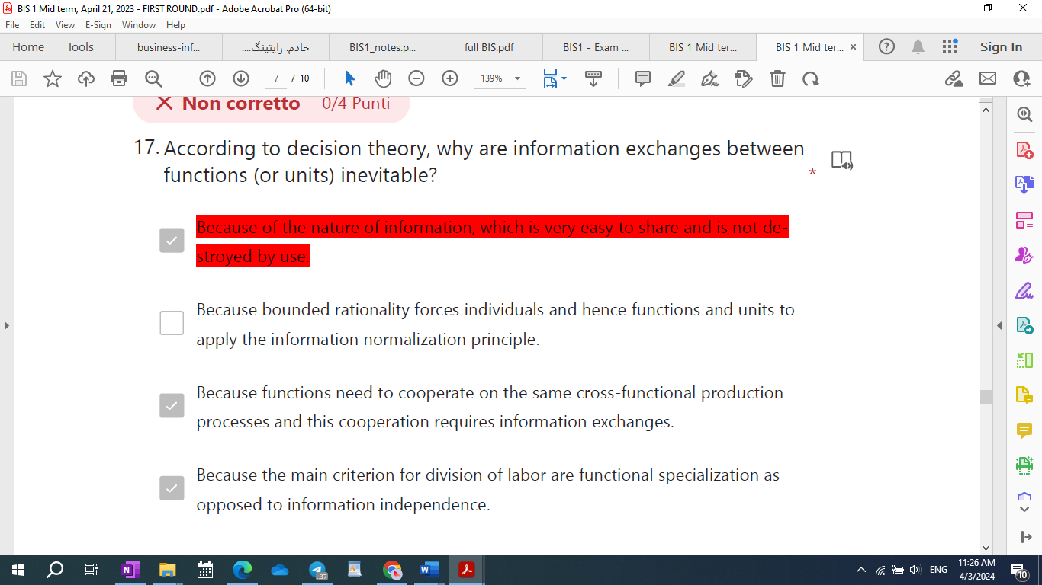

* 5-R-M: How can companies deal with environmental uncertainty according to decision theory?

1. Increase slack resources.
2. Implement market coordination mechanisms.
3. Increase information processing capacity with horizontal information systems.
4. Increase information processing capacity with vertical information systems.

* What are the activities constituting the logistic cycle in manufacturing companies?

1. Procurement, physical transformation of materials, order management.
2. Procurement, production, sales and distribution.
3. Acquisition and physical management of materials, physical transformation of materials, order management, external logistics, post sale processes.
4. Procurement, production, logistics.

* How does transaction economics overcome the limits of decision theory?

1. By considering market coordination in addition to hierarchical coordination.
2. By considering behavioral uncertainty in addition to environmental uncertainty.
3. By considering organizations as open systems.
4. By recognizing the limitations of hierarchical systems.

* How does transaction economics overcome the limits of decision theory?
* By considering behavioral uncertainty in addition to environmental uncertainty.
* By considering organizations as open systems.
* By recognizing the limitations of hierarchical systems.
* By considering market coordination in addition to hierarchical coordination.

**2. Transaction cost economics**

**3. Agency theory**

**q - how does agency theory overcome the limits of transaction economics: by recognizing that**

**1- there exists a continuum between market and hierarchy**

**2- there exists market recognition mechanisms inside organizations**

**The Impact of technical innovation on non IT organizations:**

**1. Technical innovation increases organizational efficiency, technical innovation allows company to**

**produce more with less (time, resources, people); [but not more effective]**

**2. Technical innovation enables scale economies, the word scale should suggest that we are talking**

**about economies, reduction of costs, that we obtain through the scale of the production system of**

**the organization. The larger is the organization, the greater is the scale economies. Consider the**

**acquisition of a new technology, so a company makes a buy decision, it has to make an investment,**

**that has to be amortized[2] across a larger production for the company to be able to cut on unit**

**production costs.**

**3. Technical innovation causes an increase in the optimal minimum organizational size, this is a**

**direct consequence of scale economies. That is a must for a company, because it has to grow.**

**4. Technical innovation increases individual specialization**

**5. Tayloristic assumption: there exists an organizational optimum, optimal process obtained**

**through optimal synchronization of individual tasks. Given a production goal, there is just one**

**optimal way to organize production: the one that minimize the time required from the beginning to**

**the end of the production chain.**

**6. Groupwork was not an issue (not studied)**

**7. Technical innovation increases bureaucracy and formalization of work**

**8. Overall, technical innovation increases the complexity of managerial tasks**

* 2-R-M: What are phase(s) of the CSF method?

1. **Interview with knowledge workers**
2. Robustness analysis: aimed at selecting KPIs
3. Refinement and documentation: presentation to customer, possible modifications, specification (written, but informal)
4. Predefinition: desk analysis

|  |
| --- |
| *CSF method - steps*  CSF method requires 4 phases:  • **Predefinition**: desk analysis  • **Interview**: aimed at identifying CSFs (made with top managers)  • **Robustness analysis**: defined for selecting the KPIs[3] *  • **Refinement and documentation**: go back to top managers and refine data |

Several ***determinants***of **uncertainty**

1. *Market dynamism*
2. *Number of suppliers in the market*
3. *Variety and variability of the market requirements*

**Elements are managed on standard ERP software:**

**1- user profile**

**2- Information like price and costs**

**3- documents related to business process**

**4- catalogs with the main data of the company**

**Documents are managed on standard ERP software:**

**1- Production orders**

**2- purchase orders**

**Processes are managed on standard ERP software:**

**1- Management of sales processes**

**2- Management of production**

**3- Management of purchases**

1. Management of sales processes
2. Management of production
3. Management of website
4. Management of purchases

6) Which of the following processes are managed by IC Drive

1. Warehouse

2. Production

3. Sales

4. Quality

**Three inter-function information processes** (*Order, Material, Operation*) from our computer science

Perspective

Materials requirements planning (MRP)

MRP as we said, is a first step towards the vertical integration between the operational portfolio and the

executive portfolio. By conventional, MRP is considered part of the operational portfolio and it’s called

vertical integration of the operational portfolio.

***Scope economies*** are economies that come from a better planning of how resources are used

**Concurrent engineering and inside-out production** processes enable company to produce products that

are different from the outside but are actually the same in the inside. So, the core components and also the how finished goods and also the production part of the production process is the same and shared.

If you have that, one can actually do is make your plans more flexible.

* 8-R-M: What is the role of concurrent engineering and inside-out production in MRP?

1. They are necessary to make sure that the production processes of different products are as similar as possible.
2. They are necessary to support the redesign of organizational processes to enable greater production efficiency.
3. **They are necessary to ensure that different products “look” different, while sharing many internal components.**
4. They are necessary to make sure that the number of common components across different products is maximized.

While CIM is achieve to greater efficiency, MRP is meant to achieve greater effectiveness. The way

company achieve that, with MRP is by taking advantage of scope economies. Those are economies that

come from a better planning, a better utilization of all the resources that exist in the organization, and that greater utilization is achieved by a more effective planning.

Functionalities of CIM

1. **Transformation processes**
2. **Workforce management**
3. **Plant management**
4. **Materials management**
5. **Quality management**

Before network connection, a pc was separate from other machine, only Office was used. There were also mainly two types of info: gaming and Office (made the secretary’s job more complex even if automated something). In this case, with Office, the impact of IT has been observed to lead to lower specialization. The first time that this has been observed was with secretarial work.

We now have a PC that is a tool, that is **used by office workers, knowledge workers, workers who work with information**. A PC is the first computing technology that has been applied to knowledge work, and it’s been observed that it has a very peculiar and innovative impact on organizational change.

What *knowledge workers* do in services is production and distribution (mainly production); production role is the same type of role that manual workers have in manufacturing. In a way PC are used by people that have the same role, in services, as people that have been replaced by robots in manufacturing. Of course, PC don’t replace white collars as robots did with blue collars, they just changed their jobs making it necessary to be more qualified to do an office job.

* 13-QAI-M: What is the role played by PCs in BPR (business process reengineering)?

1. PCs can be integrated with CIM and MRP.
2. PCs represent a production technology
3. PCs provide enough flexibility to support knowledge work and related decision-making activities.
4. PCs automate knowledge work

Horizontal and vertical integrated in services has occurred all at once:

• **Horizontal integration**: integration of portfolio along operational processes. *The enabling technology is Personal Computers.*

• **Vertical integration**: as a subsequence of horizontal integration; availability of operational information to the executive functionality of the portfolio of a company*. The enabling technology is Client-Server architectures.* (Horizontal -> processes; Vertical -> decision making) both steps have occurred almostsimultaneously along the timeline.

* 11-R-M: What are the steps of information transformation through ETL? *

1. Data quality control and cleaning
2. Source selection
3. Data transfer
4. Data aggregation

Information transformation (ETL)

1. Selection of data source

2. Data quality control and data cleaning

3. Data integration

4. Data aggregation

* 15-R-M: What primarily distinguishes ERP software from stand-alone targeted software is:

1. ERP has a common central database from which the various ERP software modules access information.
2. ERP is a modular software system.
3. ERP has one only common module.
4. ERP always has multiple databases, one for each module.

This question may have multiple correct options.[4]

* 17-QAI-M: Which of the following modules/sections are available on a standard ERP Software like 1C:Drive/Azienda?

1. Sales
2. Production
3. Social media management
4. Performance

Modules or sections in standard ERP

1. Sales
2. Production

* 21-R-M: Repeated What are classes of information stored in the operational database?

1. Catalog information
2. Operations planning information
3. General ledger information
4. Transaction information

|  |
| --- |
| Classes of information in the operational database  *Classes of operational information*  • ***Transaction information*:** describes the flow of operational activities.  Example: contract, start and end time of production activity  • ***Operations planning information*:** describes the objectives and the expected results of operational activities. We know that we have the operations, inter-functional information flow. We said operations are identified; each individual task is identified.  • ***Catalog information:*** represents basic knowledge and is totally independent of the flow of activity,  is relatively static. It’ doesn't flow with the inter-functional processes but it is not totally static because it changes overtime, but with respect to the activities of the processes that are performed in the organization, we can consider it rather static.  Example: product structure, phone directory |

* 24-R-M: What is SAP BW?

1. SAP BW is a tool to create dashboards
2. SAP BW is a SAP ERP
3. SAP BW is a tool used to create planning functions
4. SAP BW is a tool for datawharehouse creation of SAP

Inter-functional information in service companies(kos)

1. knowledge management
2. order management

Inter-functional information in manufacturing(mom)

1. material management
2. order management

**core functionality of ERP**:

Accounting

CIM(in manufacturing)

Human Resources = Personnel

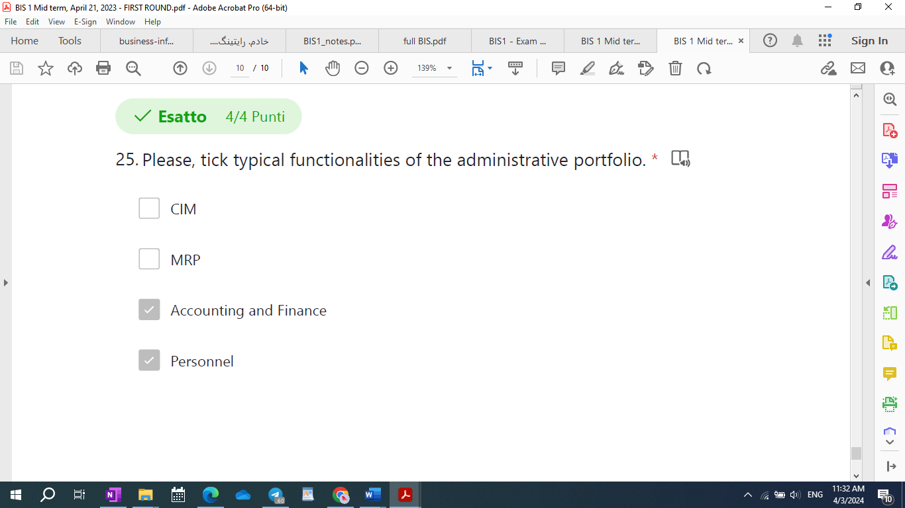

CRM is for extended ERP:

* 22-R-0: Repeated ERPs represent the last step of an integration process, since:

1. ERPs do not enable a real-time reconciliation of budgets, resource consumption, progress of operations and cashflows.
2. ERPs complete integration of operational and executive portfolios
3. ERPs complete integration of operational and administrative portfolios
4. ERPs complete integration of operational and executive with the administrative portfolio

* 23-R-M: What are correct statement(s) on CSF?

1. A CSF should be measured with one (the most significant) KPI
2. A CSF is a necessary condition for organizational success.
3. A CSF should be measured with multiple KPIs
4. CSF stands for critical success factor

11. What are correct statement(s) on CSF? *

* + 1. A CSF is a **necessary condition** for **organizational success**.
    2. A CSF should be **measured** with **multiple KPIs**
    3. A CSF should be **measured** with **robust KPIs**
    4. CSF stands for **critical success factor**

|  |
| --- |
| 1. The lower the efficiency/availability, the lower the OEE. 2. The higher the downtime, the lower the OEE. |

What are typical KPIs of salesforce automation?

1. Churn( lost client/total number of clients)
2. Productivity (total sales / number of sales employees)
3. Effectiveness of the contacts (number of contacts / number of contracts)

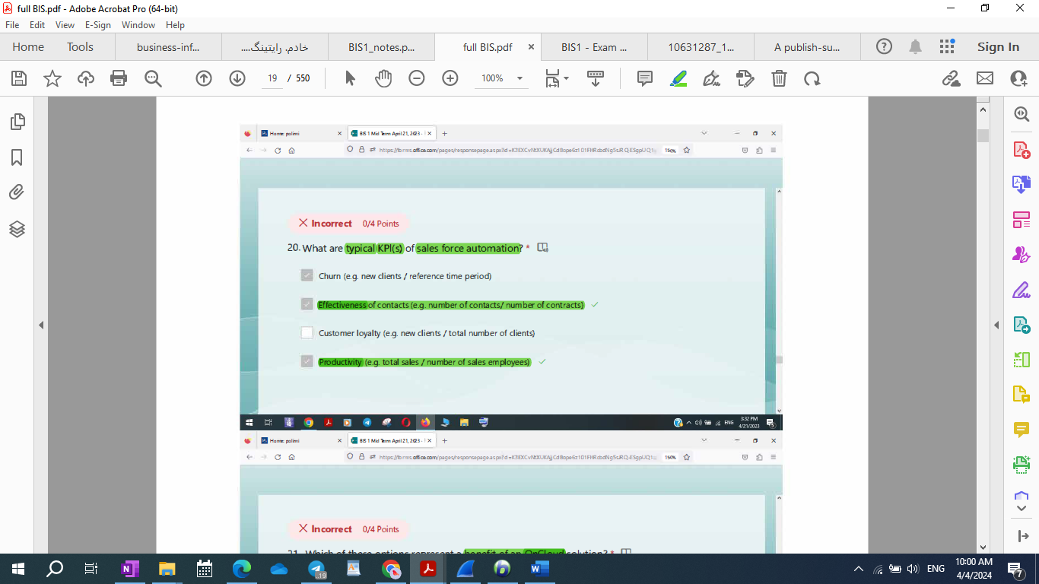

* 20-R-M: What are typical KPI(s) of sales force automation? *

1. Customer retention (e.g. new clients / total number of clients)
2. Productivity (e.g. total sales / number of sales employees)
3. Effectiveness of contacts (e.g. number of contacts/ number of contracts)
4. Churn (e.g. lost clients / total number of clients)

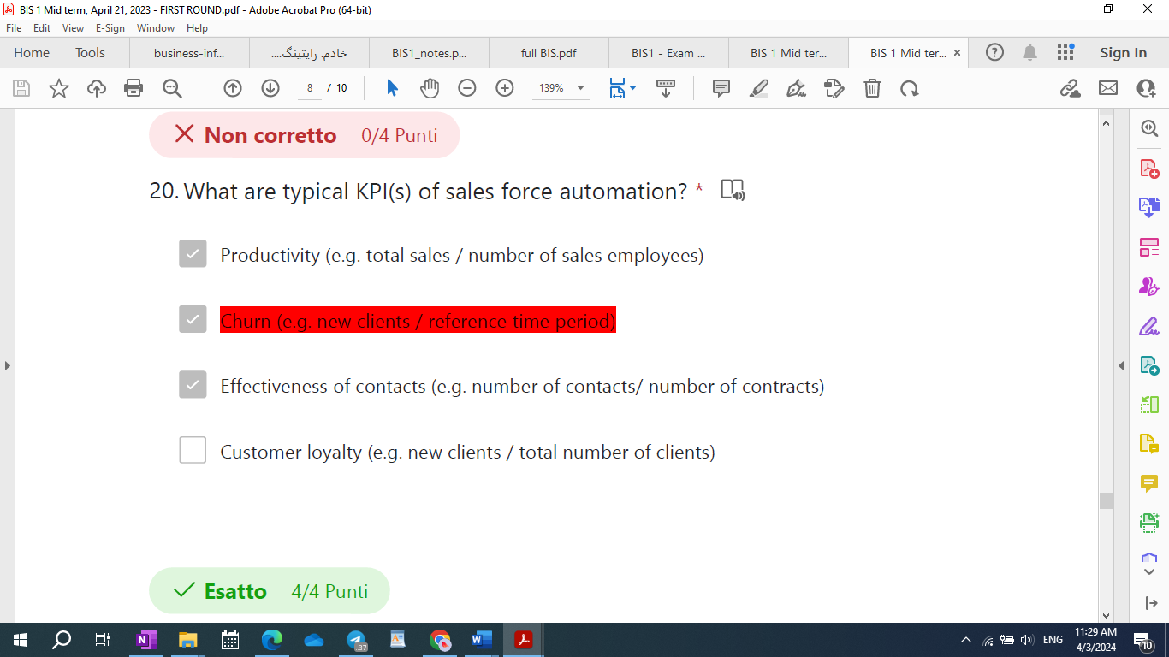

Can hierarchical control occur inside market system?

* [ ] No.
* [x] Yes, when customers can control their suppliers to some extent.
* [x] In perfect market systems, no.
* [ ] In perfect market systems, yes.

What is bounded rationality? *

* 1. Indicates limited information processing capacity of individuals.
  2. The reason why individuals cooperate.

R-0: Which costs are **lower in a hierarchy** compared to a **market coordination mechanism**?  
(4/4 Points)  
1- Coordination costs.  
2- Knowledge management costs.  
3- Transaction costs.  
4- Production costs.

**What are the correct inputs and outputs of the post settlement phase of an economic transaction?**

Input: exceptions, Output: exception management procedures.

|  |  |  |
| --- | --- | --- |
| Post settlement phase and economic transaction | Input: exceptions | Output: exception management procedure |
| Negotiation phase and economic transactions | Input: set of suppliers | Output: one supplier and new requirement (both specified a contract (SLAs)) |
| Execution phase and economic transaction | Input: Contract | Output: Product/Service and expectations with respect to SLAs |
| Match-making phase and economic transaction | Input: requirement | Output: set of candidate suppliers that satisfy initial requirements |



**Important1:** What are the characteristics of market systems?

they reduce **behavioral uncertainty** by **leveraging opportunism**.

market **coordination** involves the **execution of transaction**.

Markets replace **hierarchies**, since markets have lower production costs.

In market systems **production** costs are lower, as individuals tend to be very efficient.

**Important2:** What are the characteristics of market systems?

they reduce behavioral uncertainty by **leveraging opportunism**.

market **coordination** involves the **execution of transaction**.

Markets replace **hierarchies**, since markets have lower production costs.

In market systems **coordination** costs are lower, as individuals tend to be very efficient.

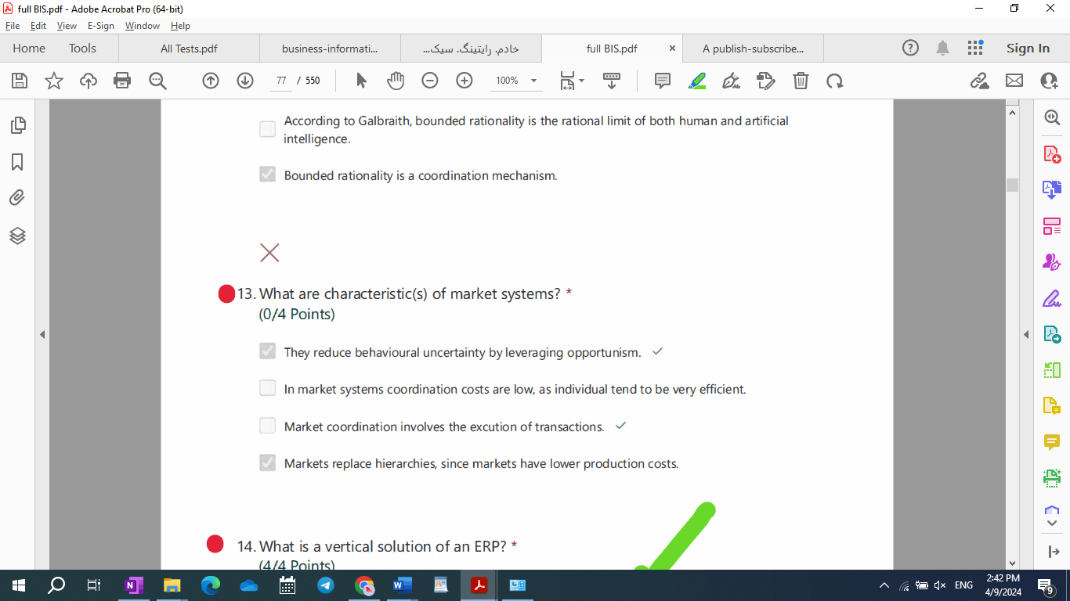

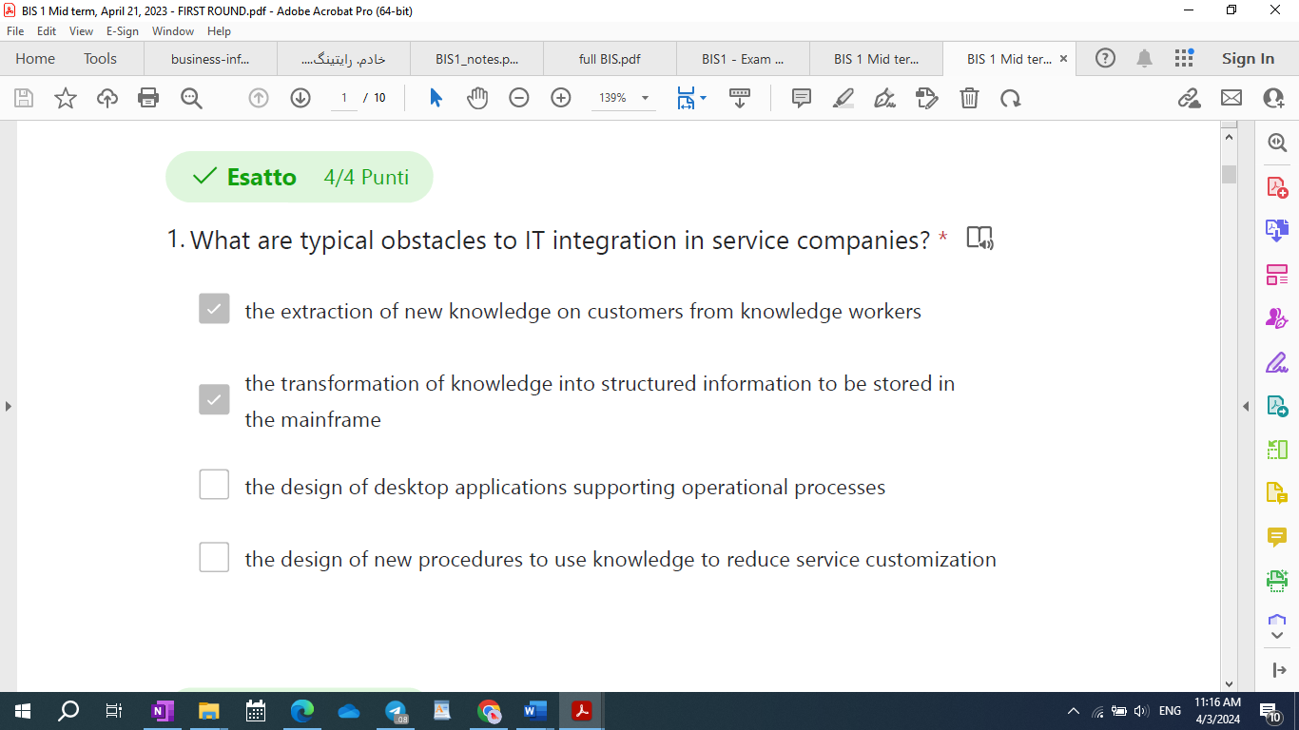

Manufacturing activity cycle (Mac DonaLd)

1. Logistic cycle
2. Development cycle



Public administration, small manufacturing company, a company doing import and export, banking and financial institutions.

* 9-R-0: Which of the following documents released during a BI project includes the Business user requirements?

1. Business Blueprint
2. User acceptance test document
3. Technical Design Document
4. Integration test documents

Which of the following are documents released during a BI project with waterfall approach?

1. Business Blueprint, a document for functional requirement collections
2. Technical Design document, a document focused on the business requirements
3. Technical Design document, a document focused on the technical solution
4. Business Blueprint, a document for resource planning

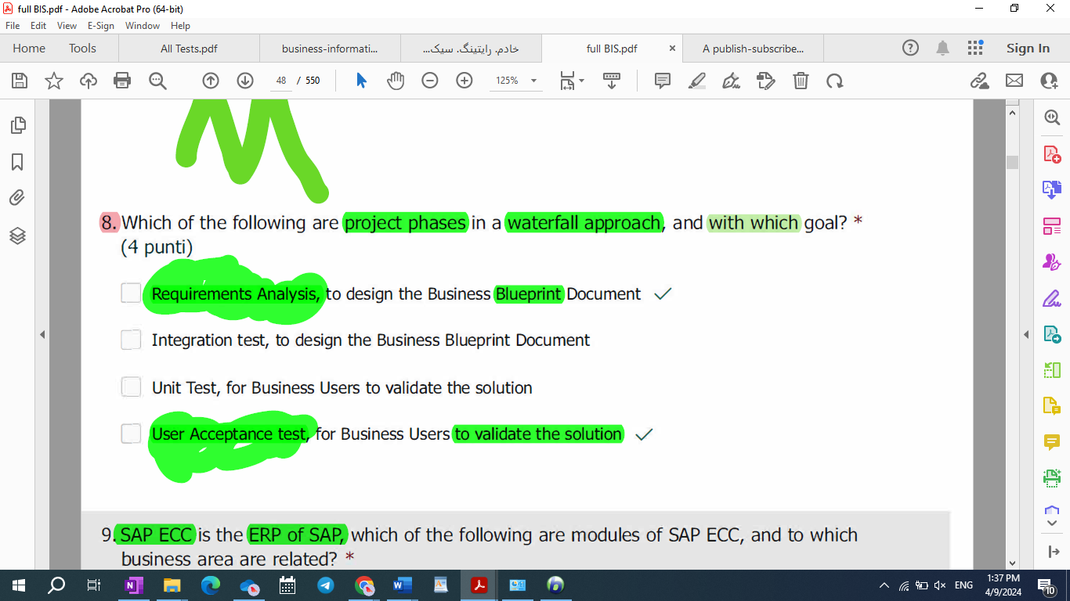

R-0: Repeated Which of the following Test procedure is performed with Business users?

1. Software installation test
2. User Acceptance Test
3. Integration Test
4. Unit Test

Why is the meaning of having a “balanced” set of KPIs to calculate the incentives of call-center operators? *

1. It means measuring a balanced set of indicators such as average call time, first call resolution, customer satisfaction.
2. It means sizing the call center to minimize customers’ waiting time.
3. It means measuring both efficiency and effectiveness.
4. It means measuring the efficiency of a team as opposed to an individual operator.

* Why is the meaning of having a "balanced" set of KPIs to calculate the incentives of call-center operators? (x3)

1. It means measuring a balanced set of indicators such as average call time, first call resolution, customer satisfaction.
2. It means measuring both efficiency and effectiveness.

* 24-R-M: According to decision theory, why are information exchanges between functions (or units) inevitable?

1. Because functions need to cooperate on the same cross-functional production processes and this cooperation requires information exchanges.
2. Because bounded rationality forces individuals and hence functions and units to cooperate in information processing tasks to **reach a common goal**.
3. Because the main criterion for division of labor are functional specialization as opposed to information independence.
4. Because of the nature of information, which is very easy to share and is not destroyed by use.

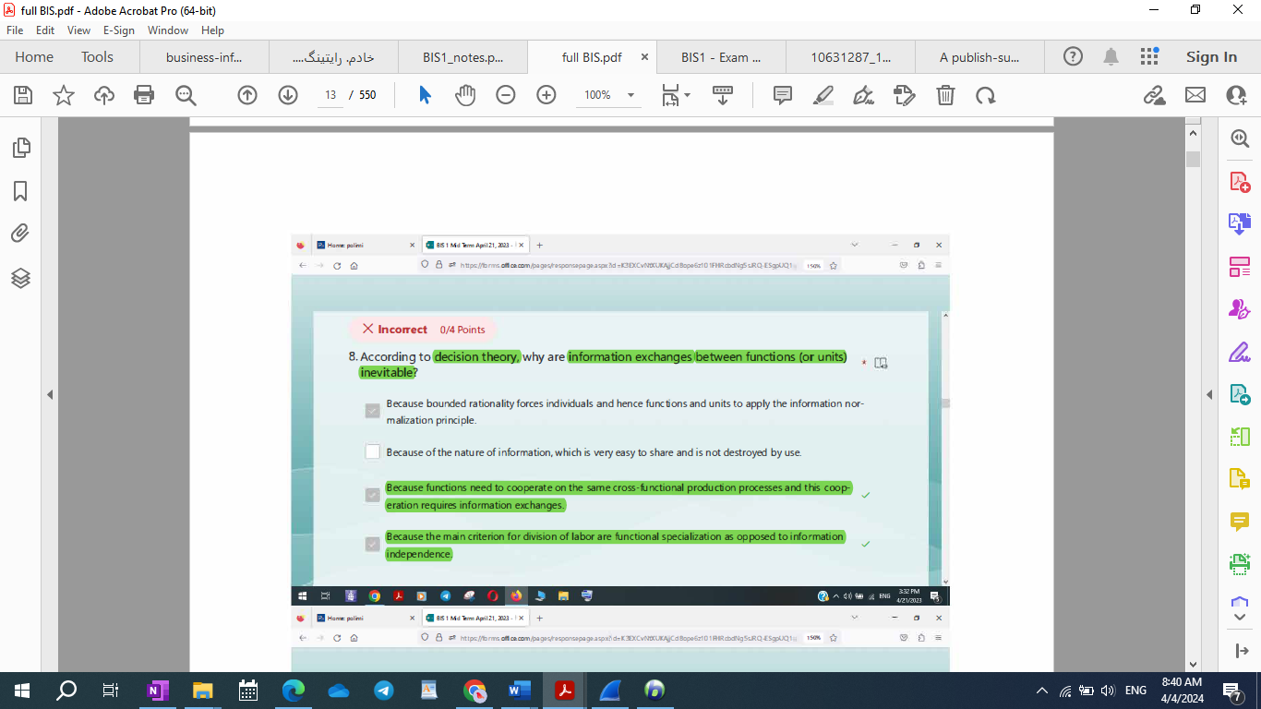

IT integration in service companies

What are obstacle(s) to IT integration in service companies?

* [x] The learning process involved by knowledge management.
* [ ] The breadth of the service industry in terms of sub-industries.
* [ ] The lack of automation technologies.
* [ ] The skill shortage.

**Which of the following functionalities are available on standard ERP Software 1C:Drive/azienda (tick all the correct ones)?**

[x] Multi-languages

To manage purchases

To manage accountancy

[x] Demand planning

[x]management of production order

[x] To get useful reports regarding your business

[x] Communication with instant messaging app like telegram

[x] Communication with telegram and others instant messaging

[x] Import/Export of documents in various format

[x] Generation and copy of documents

[x] Personalization of user interface

**What you can do with ERP Software 1C:Drive/Azienda (tick the correct ones)?**

[x] Manage Bills of Materials and Production Order

[ ] Manage the company blog

[x] Calculating the profit of a client order

[x] Manage orders from client calculating the profit

[x] Comparing Supplier offers

[ ] To manage directly a web-commerce site

[x] Manage supply of goods

[x] Manage supply of goods comparing offer from various supplier

[x] Manage orders from Client

* 19-R-M: Why **doesn’t** non-IT technical innovation have an impact on scope economies?

1. Because scope economies are not related to innovation.
2. Because scope economies are inherently different from scale economies and do not originate from greater efficiency of production processes.
3. Because increasing scope economies requires better coordination and non-IT technologies do not support coordination.
4. Because non-IT technical innovation increases organizational effectiveness only.

******************************\

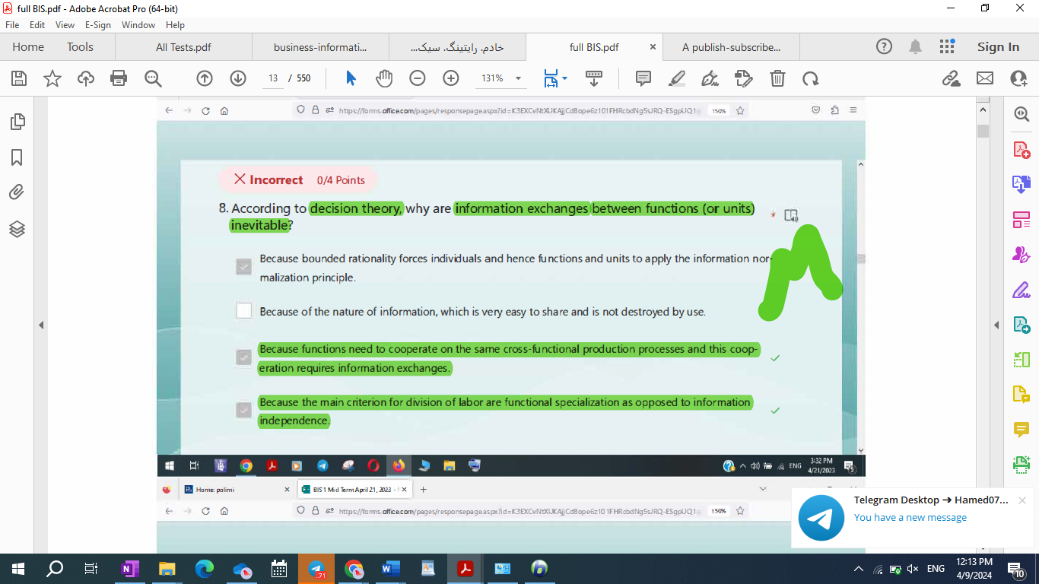

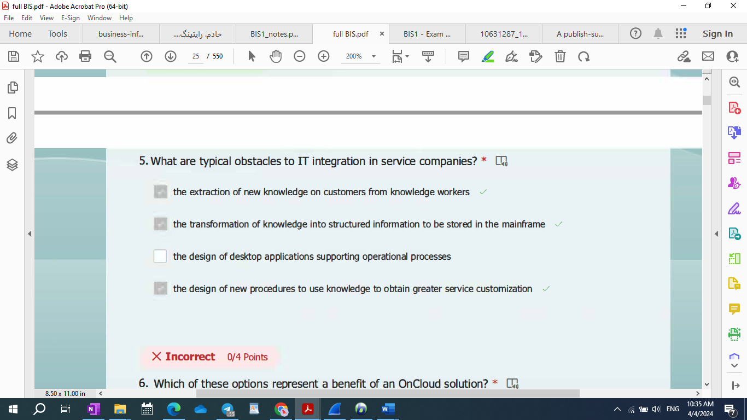

* 22-R-M: What are typical obstacles to IT integration in service companies? *

1. the extraction of new knowledge on customers from knowledge workers
2. the transformation of knowledge into structured information to be stored in the main frame.
3. the design of desktop applications supporting operational processes
4. the design of new procedures to use knowledge to **reduce** service customization

* 21-R-M: What are typical obstacles to IT integration in service companies? *

1. the extraction of new knowledge on customers from knowledge workers
2. the transformation of knowledge into structured information to be stored in the main frame.
3. the design of desktop applications supporting operational processes
4. the design of new procedures to use knowledge to **obtain greater** service customization.

Why is knowledge management complex? *

1. Because it involves the use of PCs and hence a significantly broader software variety.
2. Because it requires the design of new procedures to use knowledge to obtain greater service customization.
3. Because unstructured knowledge must be transformed into structured information be stored in the mainframe.
4. Because it involves the extraction of new knowledge on customers from knowledge -workers.

******************************************************/

Please, tick consolidated belief(s) tieing technical innovation with organizational change for non-IT technologies.

* [ ] Technical innovation increases organizational efficiency and **effectiveness**.
* [x] Technical innovation enables scale economies
* [x] There exists an **organlizational optimum**, optimal process obtained through optimal synchronization of individual tasks.
* [x] **Technical innovation does not enable scope economies.**
* [x] Technical innovation increases individual specialization.
* [ ] Technical innovation simplifies management.
* [ ] Technical innovation enables scope economies.

[ ] Technical innovation increases bureaucracy, but does not affect the formalization of work.

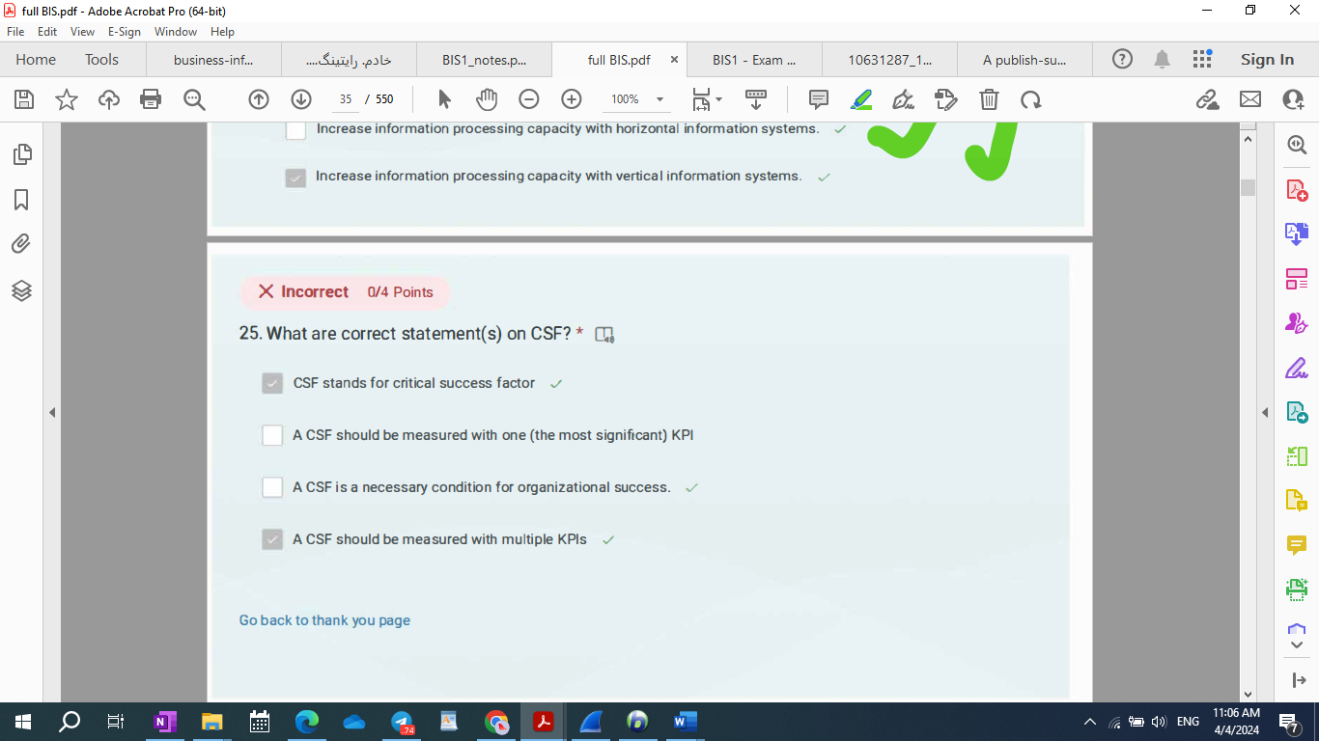

* 23-R-M: What are correct statement(s) on CSF?

1. A CSF should be measured with one (the most significant) KPI
2. A CSF is a necessary condition for organizational success.
3. A CSF should be measured with multiple KPIs
4. CSF stands for critical success factor

* Repeated What are phase(s) of the CSF method?

1. Refinement and documentation: presentation to customer, possibile modifications, specification (written, but informal)
2. Robustness analysis: aimed at selecting KPIs
3. Interview with knowledge workers
4. Predefinition: desk analysis

What are the steps of the CSF method?

1. Interview, analysis, documentation, implementation

2. Preparation, documentation, interview, reporting

**3. Preparation, interview, robustness analysis, refinement**

4. Preparation, interview, reporting, implementation

Please, tick the correct definition of IT intensity.

1. IT intensity is the actual ability of IT to satisfy the information processing requirements of organizational processes.
2. IT intensity is the degree to which a company’s management considers IT as a strategic lever:
3. IT intensity represents the size and complexity of the information used by the processes of an organization.
4. IT intensity is the organizational consequence of environmental uncertainty, as companies can handle uncertainty with IT.
5. IT intensity is the organizational consequence of environmental uncertainty, as companies can handle uncertainty with IT.

How does agency theory overcome the limits of transaction economics? * (0/4 Points)

* 1. By studying employment contracts as a special-purpose transaction.
  2. By recognizing that there exists a continuum between markets and hierarchies.
  3. By recognizing that hierarchies can fail and can be replaced by market systems.
  4. By recognizing that there exist market coordination mechanisms inside organizations.

What are drivers of IT intensity according to Porter?

1. Degree to which information processing activities are structured and, thus, can be easily translated into a computing procedure (predetermined steps and decision tree).
2. Volumes, i.e. the amount of information to be processed.
3. Frequency with which a given operation is repeated.
4. Computational complexity of operations, the simpler, the better.

6) Which of the following processes are managed by IC Drive

1. Warehouse

2. Production

3. Sales

4. Quality

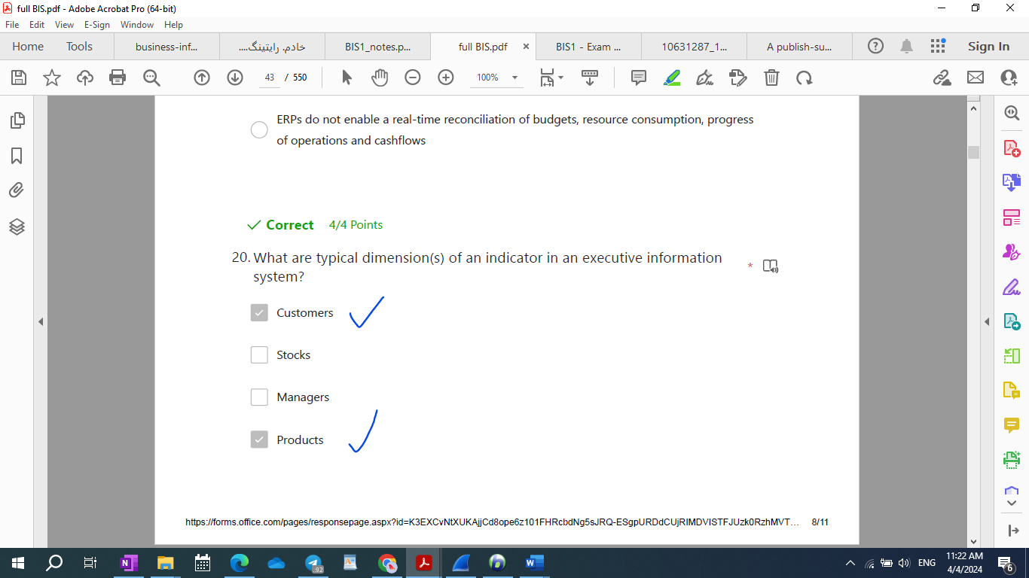

* The knowledge management process requires: *
  1. the extraction of new knowledge on customers from knowledge workers,
  2. the transformation of this knowledge into structured information to be stored in the mainframe,
  3. the design of new procedures to use this knowledge to obtain greater production efficiency
  4. A learnig process

**Why are PCs enabling technologies of Business Process Reengineering (that is horizontal and vertical**

**integration of the operational portfolio in service companies)?**

1. PCs are enabling technologies of BPR since they help horizontal coordination.

**2. PCs are enabling technologies of BPR since they help individual workers overcome the**

**boundaries of their individual rationality and become generalists.**

**3. PCs are enabling technologies of BPR since they support the knowledge management process.**

**4. PCs are enabling technologies of BPR since they represent the key technology to collect operating**

**information in electronic format at the time when it is first created (similar to robots in**

**manufacturing).**

* 10-Among the following, select (tick) the correct statement(s) on ERP software 1C:Drive: *
  1. It can be installed only on premises, not allowed cloud access.
  2. It is a software that allows to manage both accountancy and company business processes.
  3. It supports multiple languages interface, multiple currencies and multiple companies.
  4. It can be used only in Cloud.

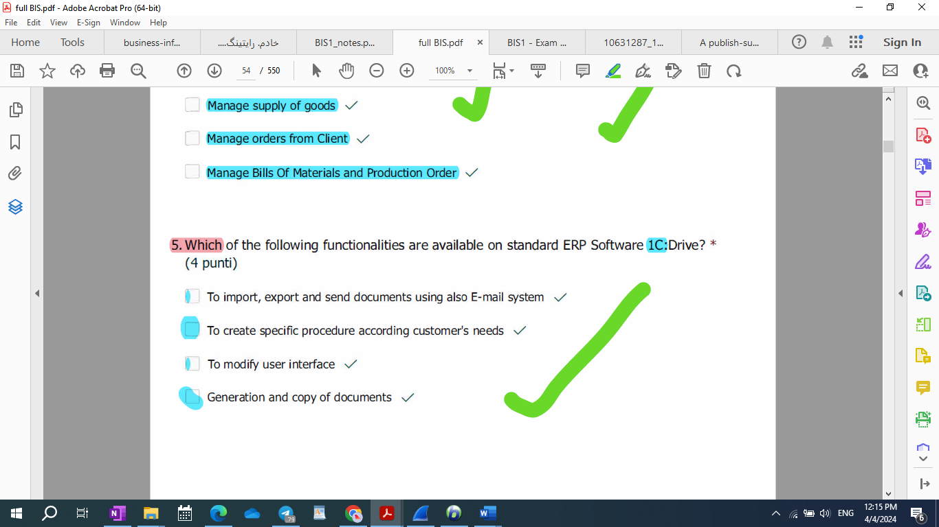

12-What is bounded rationality? *

1. Bouded rationality represents the limited information processing capacity (IPC) of

individuals.

1. Bounded rationality is the reason why individuals cooperate.
2. According to Galbraith, bounded rationality is the rational limit of both human and

artificial intelligence.

1. Bounded rationality is a coordination mechanism.

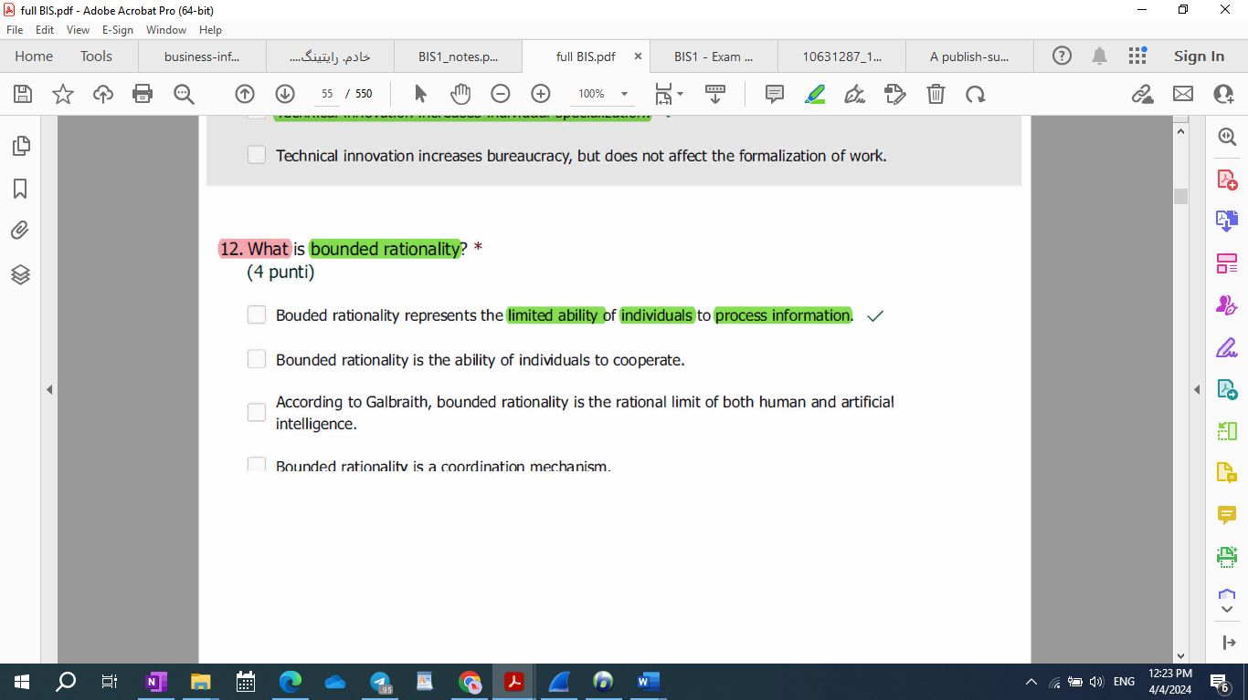

What is a CSF? *

* 1. CSF stands for critical success factor
  2. A critical success factor is a business decision variable critical for the success of the whole company, i.e. a must for success (necessary condition)
  3. A CSF is a key performance indicator
  4. A CSF is a set of key performance indicators

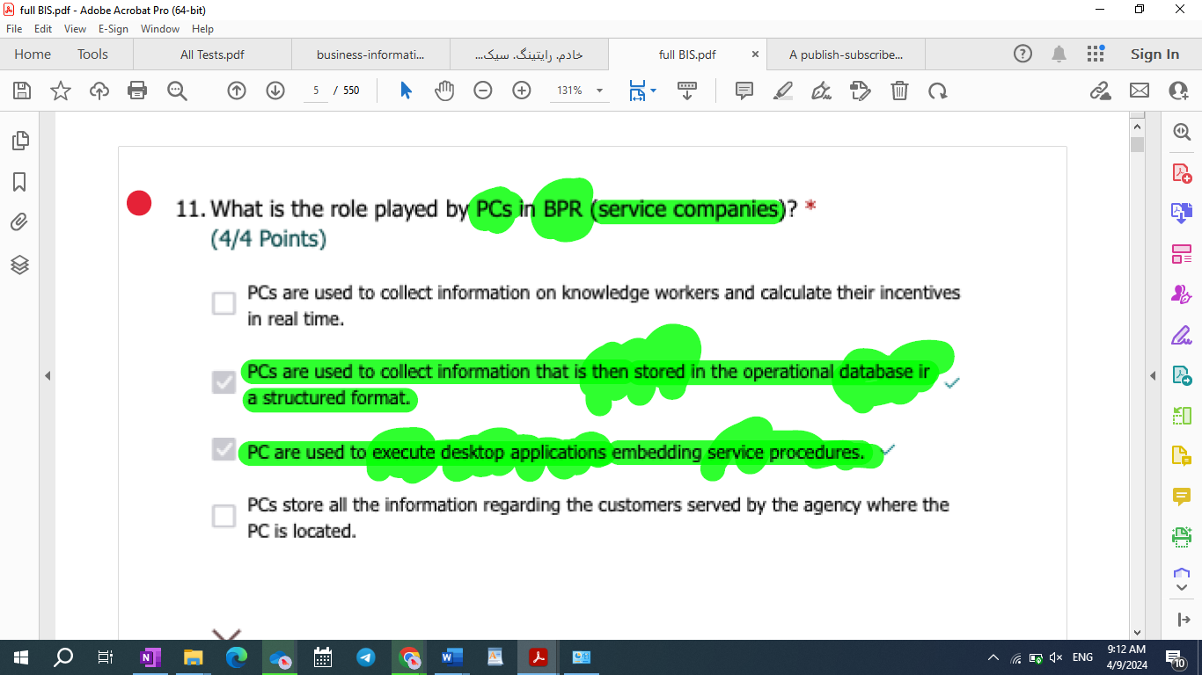

* 13-R-M: What is the role played by PCs in BPR (business process reengineering)?

1. PCs can be integrated with CIM and MRP.
2. PCs represent a production technology
3. PCs provide enough flexibility to support knowledge work and related decision-making activities.
4. PCs automate knowledge work

What is the role played by IT in the service industry? *

(0/4 Points)

1. Distribution technology.
2. Management technology.
3. Production technology.
4. Support to optimization of production resources.

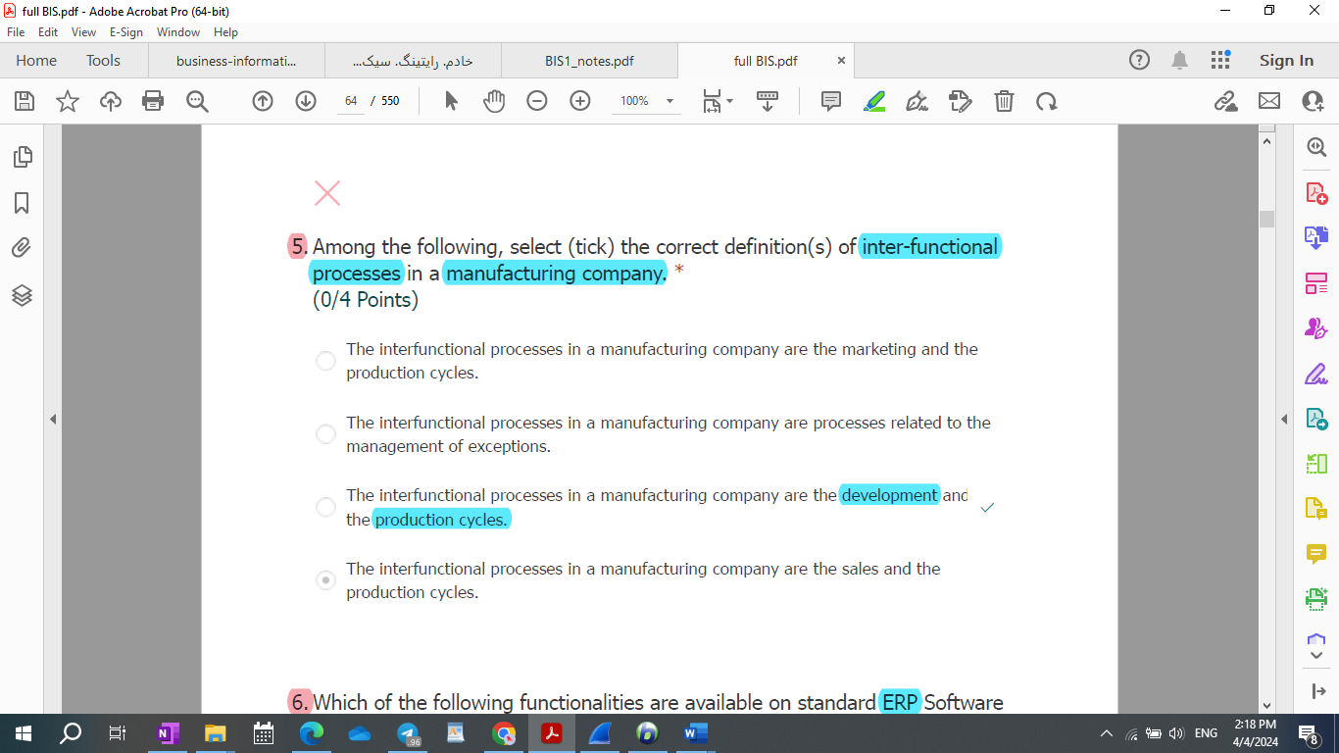

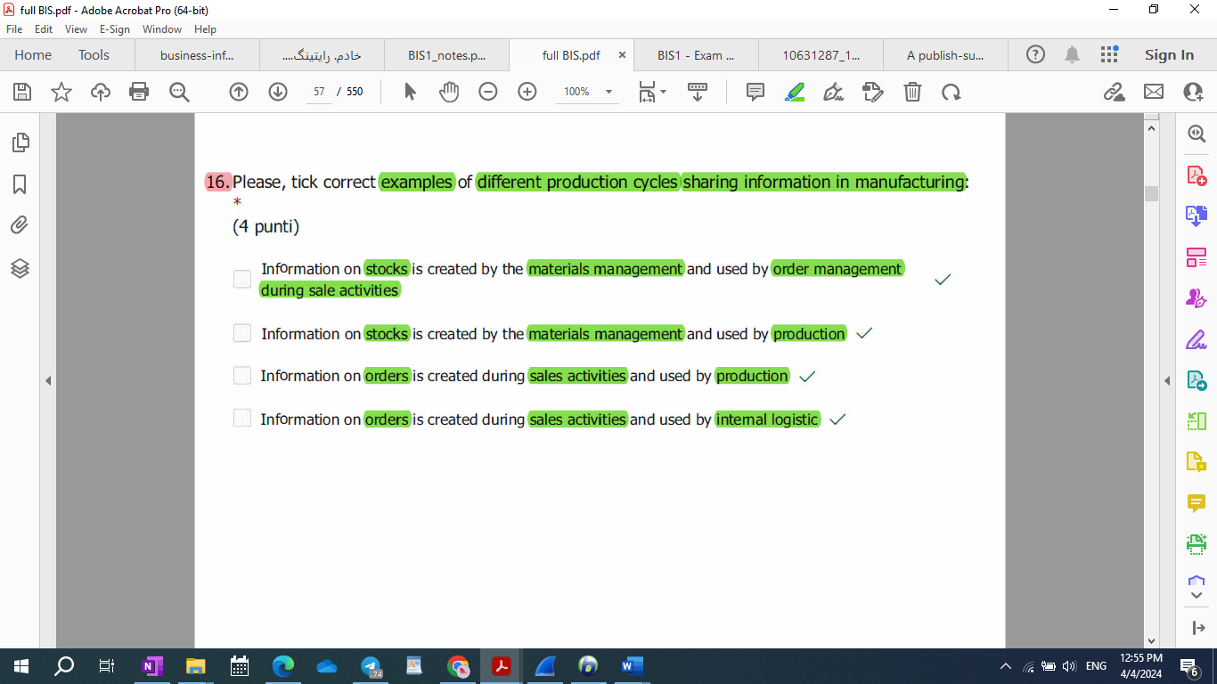

* Please, tick correct examples of different production cycles sharing information in manufacturing:

1. Information on stocks is created by the materials management and used by order management during sale activities
2. Information on stocks is created by the materials management and used by production
3. Information on orders is created during sales activities and used by **R&D**
4. Information on orders is created during sales activities and used by internal logistic

* Please, tick correct examples of different production cycles sharing information in manufacturing:

1. Information on stocks is created by the materials management and used by order management during sale activities.
2. Information on stocks is created by the materials management and used by production.
3. Information on orders is created during sales activities and used by production.
4. Information on orders is created during sales activities and used by internal logistic.

* Different production cycles share information, e.g.:
  1. Information **on stocks** is **created by** the **materials management** and **used by** **order management** during sale activities.
  2. Information **on stocks** is **created by** the **materials management** and **used by** **production.**
  3. Information **on orders** is **created during** **sales activities** and **used by** **production.**
  4. Information **on orders** is **created during** **sales activities** and **used by** **internal logistic.**

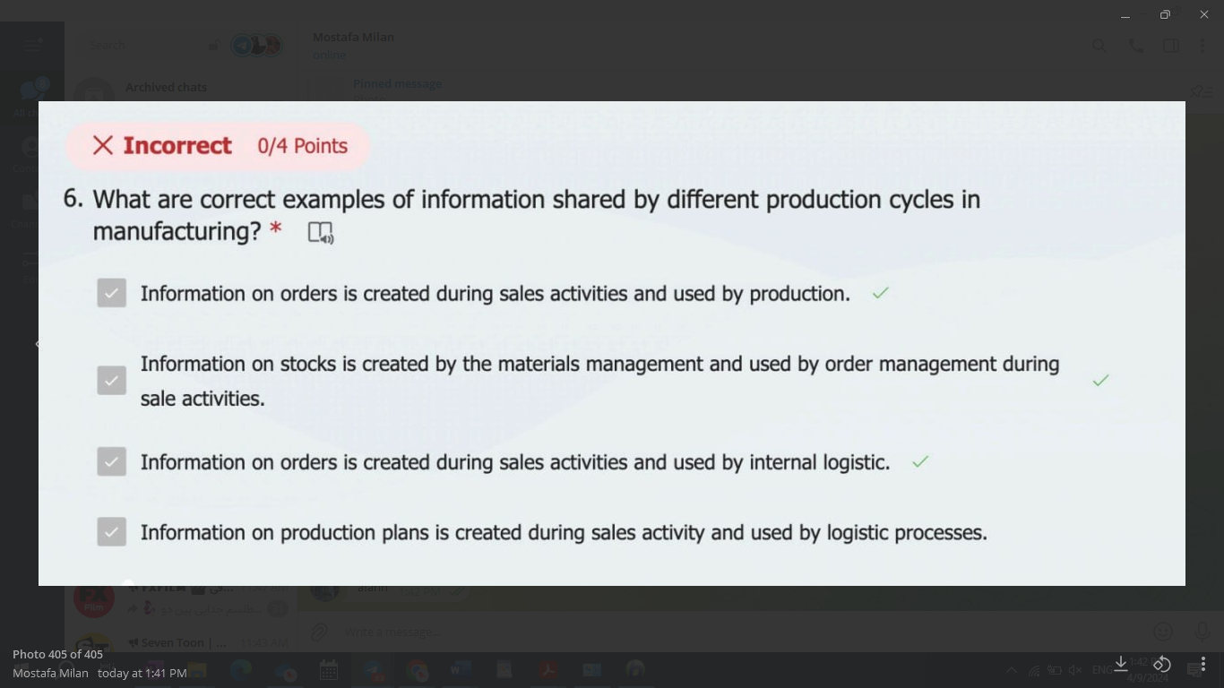

|  |  |  |  |
| --- | --- | --- | --- |
| Information on stocks | Created by material management | Use by order management + production |  |
| Information on orders | Created during the sales activities | Used by production + internal logistic | Used by R&D |
| On production plans | Created during sales activities |  | Used by logistic processes |

|  |  |  |
| --- | --- | --- |
| Information stack created by material management used by | Order management during sales activities – used by | production |
| internal logistics |
| production |  |

R-M: Repeated What is (are) the purpose(s) of an ETL procedure?

1. Allow to register documents of different business areas in a single database
2. **Extract** data from a source perform data modeling and upload data in a target structure
3. Allow analytics on different data sources simultaneously
4. **Extract** data from a system to import them in a different one

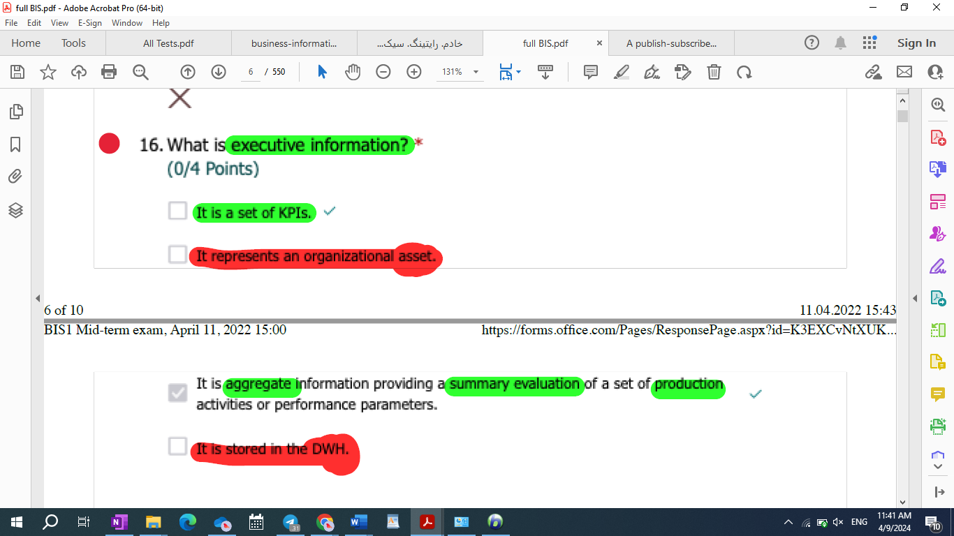

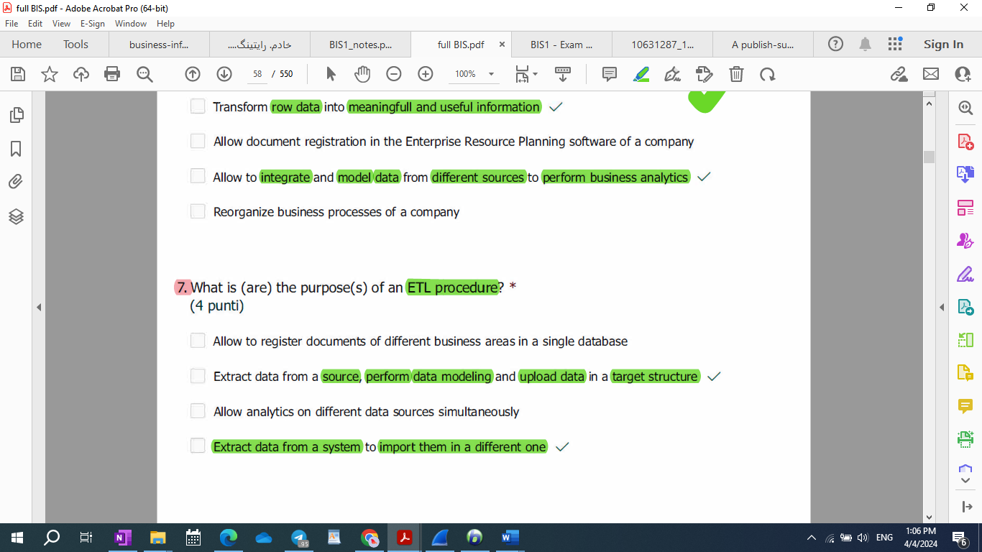

What are characteristic(s) of market systems? *

1. They reduce behavioural uncertainty by leveraging opportunism.
2. In market systems **production costs are low**, as individuals tend to be **very efficient**.
3. Market coordination involves the execution of transactions.
4. Markets replace hierarchies, since markets have lower production costs.

What are characteristic(s) of market systems? *

1. They reduce behavioural uncertainty by leveraging opportunism.
2. In market systems production costs are low, as individual tend to be very efficient.
3. Market coordination involves the excution of transactions.
4. Markets replace hierarchies, since markets have lower production costs.

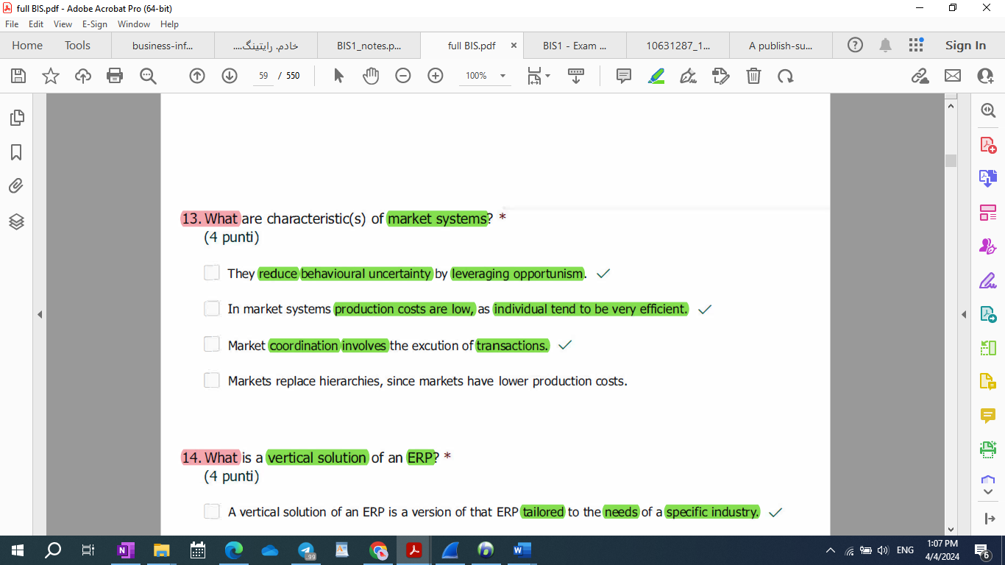

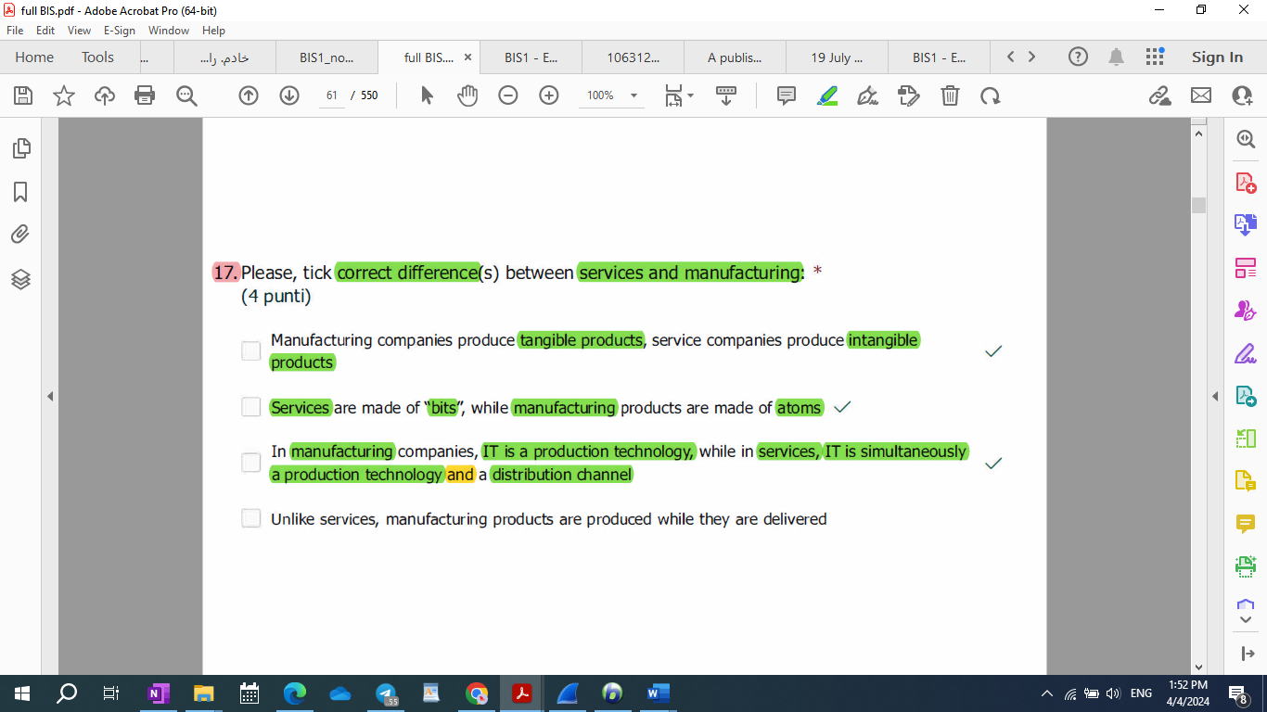

* Repeated Please, tick correct difference(s) between services and manufacturing: *

1. Manufacturing companies produce tangible products, service companies produce intangible products
2. Services are made of “bits”, while manufacturing products are made of atoms
3. In manufacturing companies, IT is a production technology, while in services, IT is simultaneously a production technology and a distribution channel
4. Unlike services, manufacturing products are produced while they are delivered

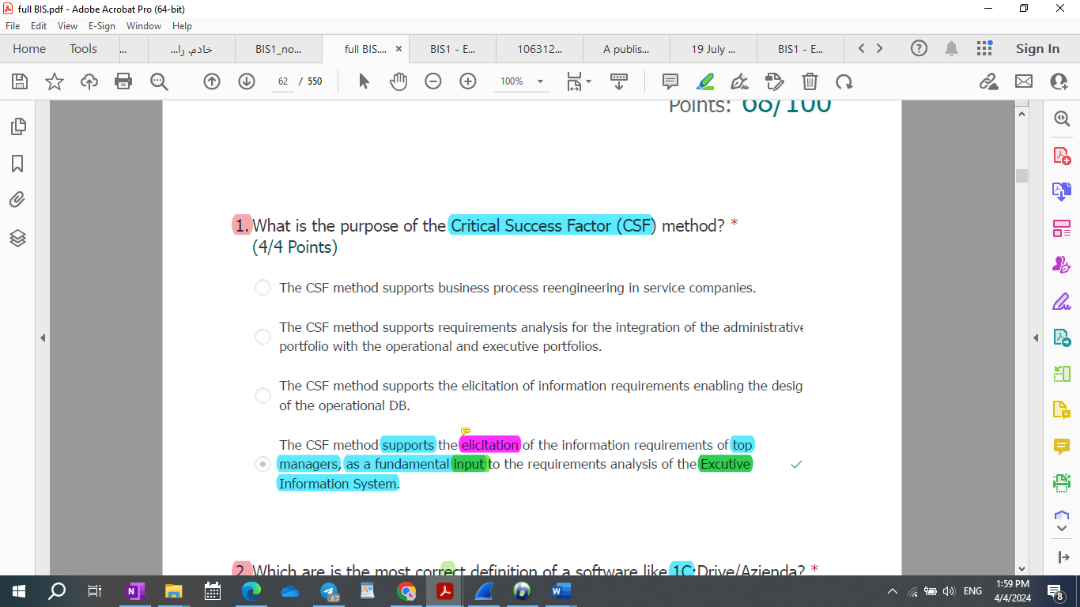

Repeated: What is the purpose of the Critical Success Factor (CSF) method? *

1. The CSF method supports the elicitation of information requirements enabling the design of the operational DB.
2. The CSF method supports the elicitation of the information requirements of top managers, as a fundamental input to the requirements analysis of the Excutive Information System.
3. The CSF method supports requirements analysis for the integration of the administrative portfolio with the operational and executive portfolios.
4. The CSF method supports business process reengineering in service companies.

45 - What is the purpose of the Critical Success Factor (CSF) Method? S P

* 1. The CSF Method support the elicitation of the information requirements of top managers, as a fundamental input to the requirements analysis of the Executive Information System.
  2. The CSF Method support requirements analysis for the integration of the administrative portfolio with the operational and executive portfolio.
  3. The CSF Method support the elicitation of the information requirements enabling the design of the operational DB.
  4. The CSF Method support the process reengineering in service companies.

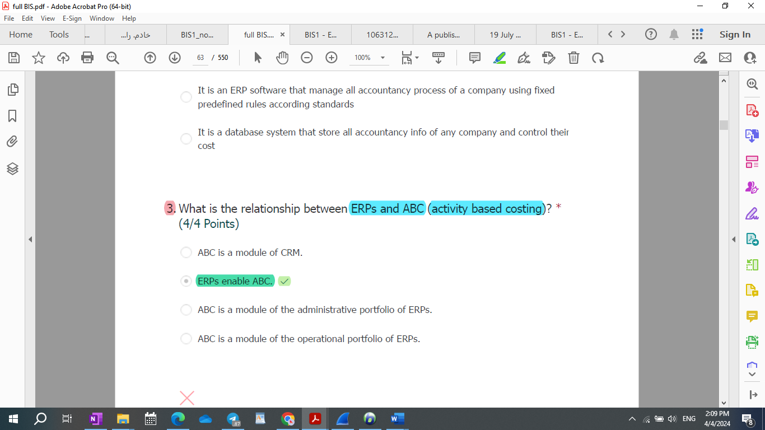

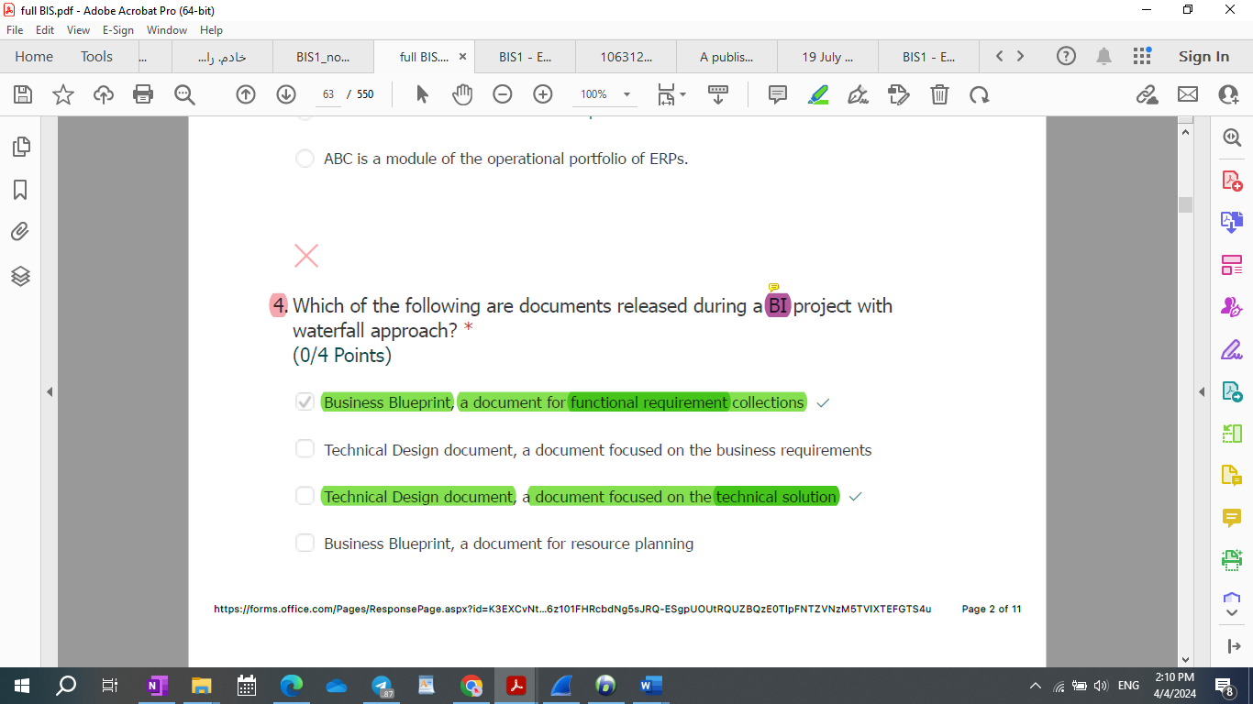

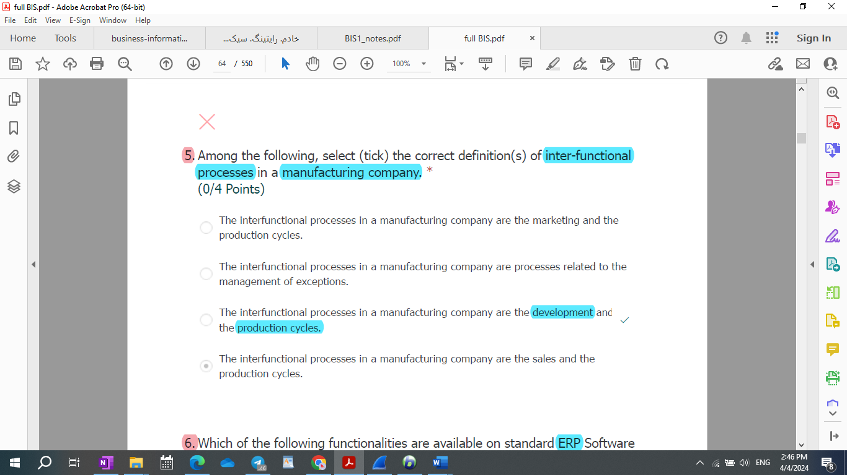

Among the following, select (tick) the correct definition(s) of inter-functional processes in a manufacturing company. *

(4/4 Points)

* 1. The interfunctional processes in a manufacturing company are the sales and the production cycles.
  2. The interfunctional processes in a manufacturing company are the development and the production cycles.
  3. The interfunctional processes in a manufacturing company are the marketing and the production cycles.
  4. The interfunctional processes in a manufacturing company are processes related to the management of exceptions.

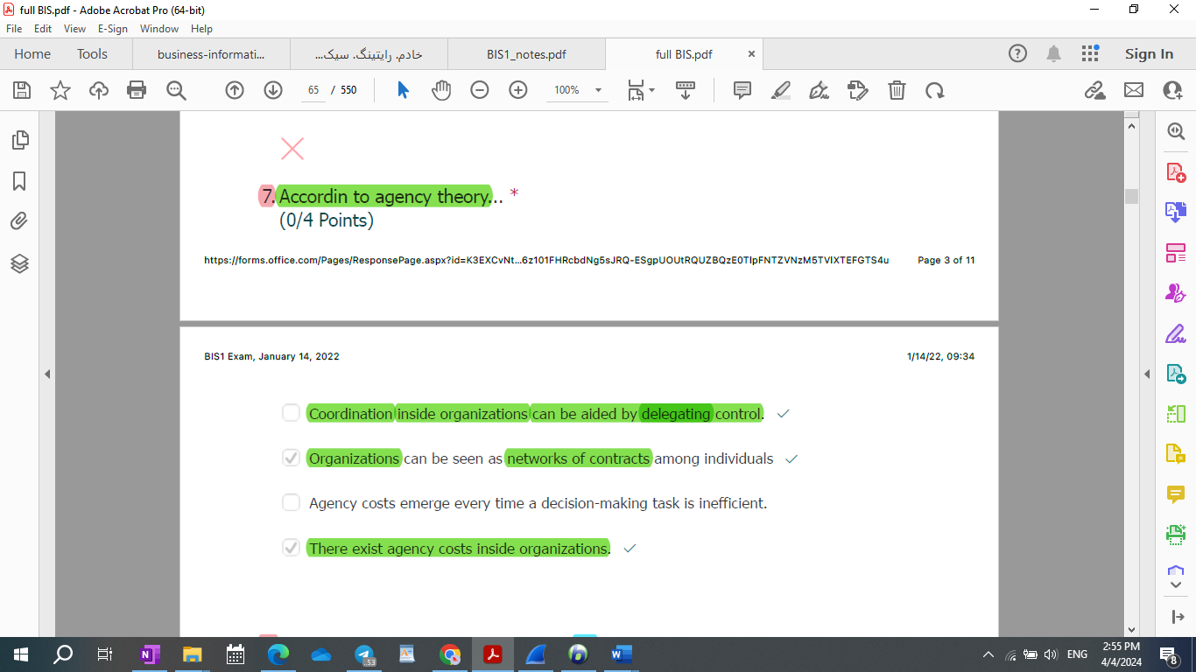

* 1. Organizations are seen as networks of contracts among individuals
  2. Agency costs emerge every time a decision-making task is inefficient.
  3. Coordination inside organizations can be based only on command and control.
  4. There exist transaction costs inside organizations.

According to agency theory… *

1. Coordination inside organizations can be aided by delegating control.
2. Organizations can be seen as networks of contracts among individuals
3. Agency costs emerge every time a decision-making task is inefficient.
4. There exist agency costs inside organizations.

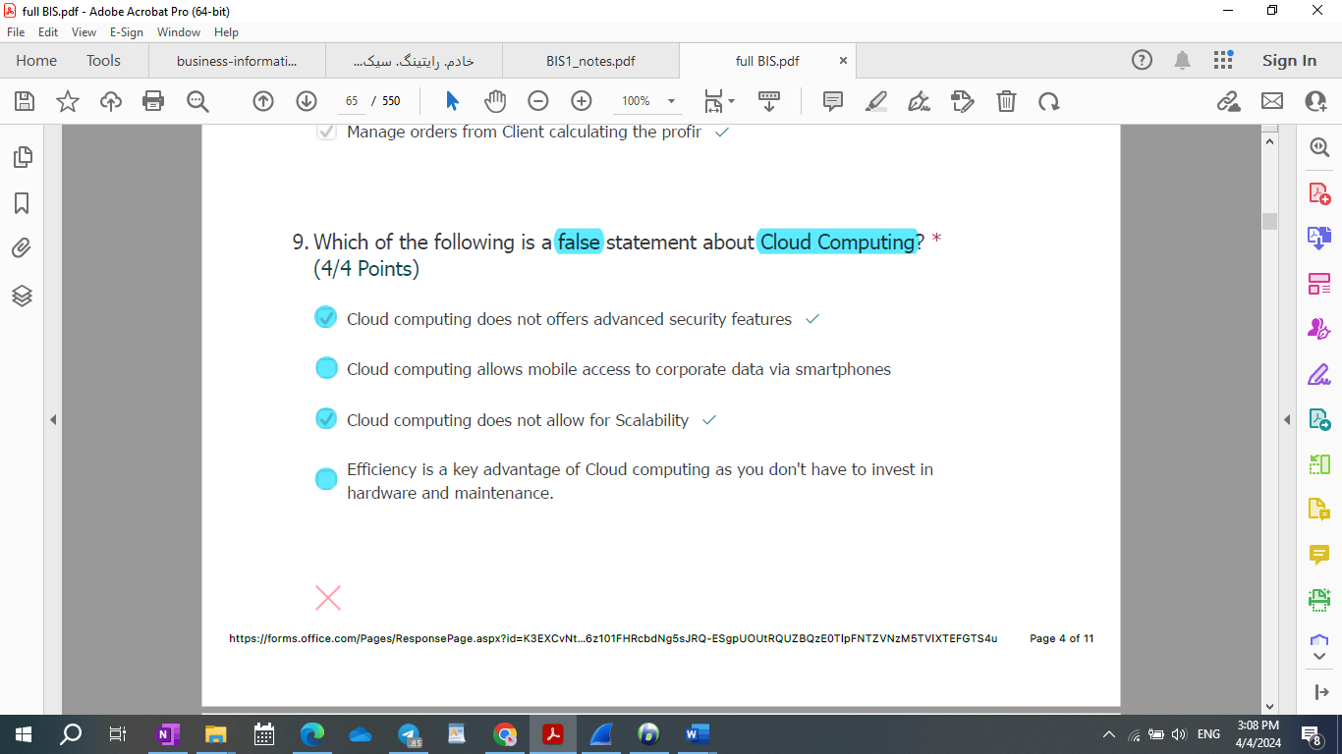

* Which of the following is a false statement about Cloud Computing?
  1. Cloud computing does not allow for Scalability.
  2. Cloud computing allows mobile access to corporate data via smartphones
  3. Cloud computing does not offers advanced security features
  4. Efficiency is a key advantage of Cloud computing as you don’t have to invest in hardware and maintenance.

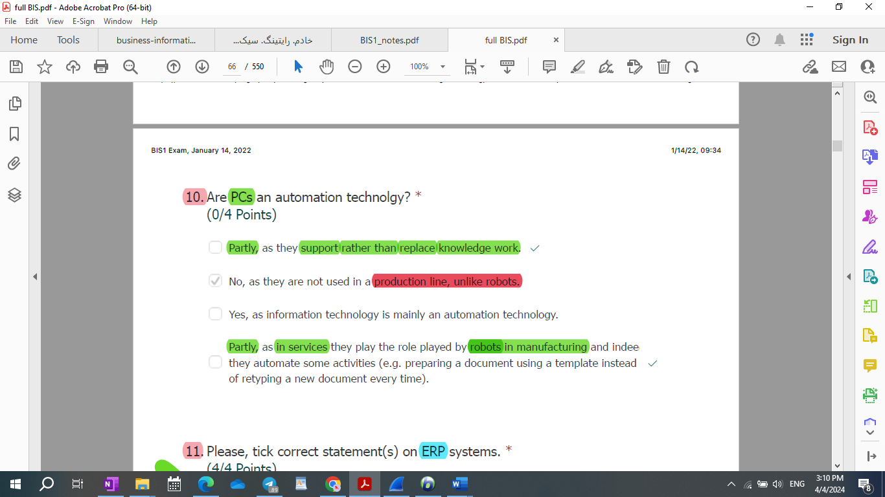

Are PCs an automation technolgy? *

1. Yes, as in services they play the role played by robots in manufacturing.
2. No, as they support rather than replace knowledge work.
3. No, as they are not used in a production line, unlike robots.
4. Yes, as information technology is mainly an automation technology.

* Are PCs an automation technolgy?
* [ ] No, as they are not used in a production line, unlike robots.
* [x] No, as they support rather than replace knowledge work.  
   No
* [ ] Yes
* [ ] Yes, in manufacturing
* [ ] Yes, in services
* [ ] Yes, as in services they play the role played by robots in manufacturing
* [ ] Yes, as information technology is mainly an automation technology

Are PCs an automation technolgy? *

1. Partly, as they support rather than replace knowledge work.
2. No, as they are not used in a production line, unlike robots.
3. Yes, as information technology is mainly an automation technology.
4. Partly, as in services they play the role played by robots in manufacturing and indee they automate some activities (e.g. preparing a document using a template instead of retyping a new document every time).

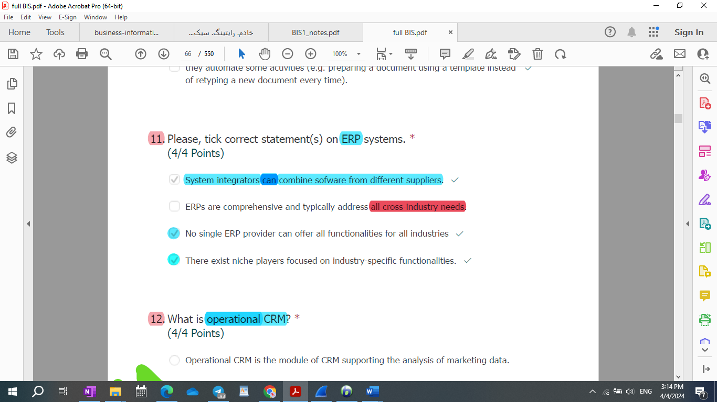

Please, tick correct statement(s) on ERP systems.

1. System integrators can combine software from different suppliers.
2. ERPs are comprehensive and typically address **all** cross-industry needs.
3. No single ERP provider can offer all functionalities for all industries
4. There exist niche players focused on industry-specific functionalities.

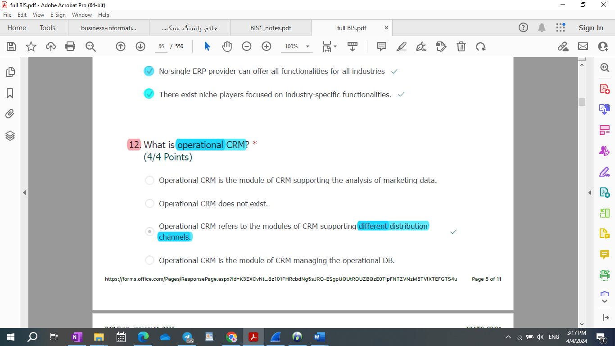

What is operational CRM? *

(4/4 Points)

Operational CRM is the module of CRM supporting the analysis of marketing data.

Operational CRM is the module of CRM managing the operational DB.

Operational CRM does not exist.

Operational CRM refers to the modules of CRM supporting different distribution channels.

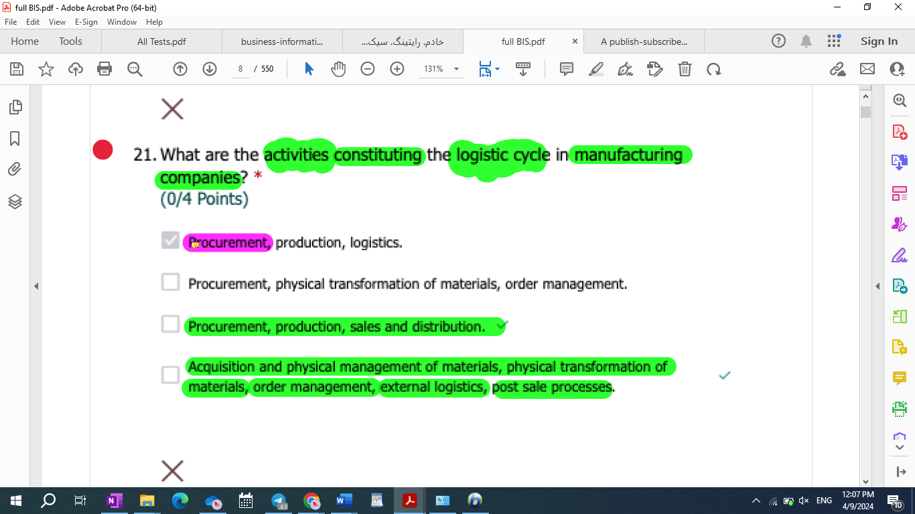

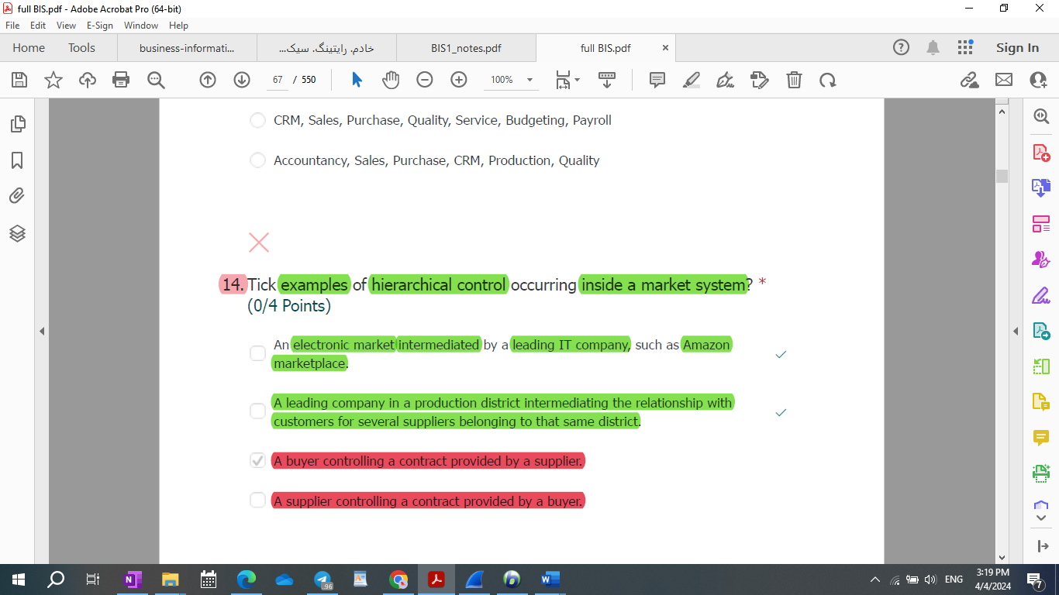

* 6-R-M: Please tick correct statement(s) on hierarchical control in market systems:

1. In non perfect markets, customers may have some level of hierarchical control on their **customers’ production processes**.
2. Market and hierarchies are separate coordination systems that can mix only inside organizations.
3. In non perfect markets, customers can control their suppliers to some extent.
4. Hierarchical control does not exist **in perfect market systems.**

* Can hierarchical control occur inside market system? * (4/4 Points)  
  1- In perfect market systems, yes.  
  2- In perfect market systems, no.   
  3- Yes, when customers can control their suppliers to some extent.  
  4- No.
* Tick examples of hierarchical control occurring inside a market system? (0/4 Points)

1. An electronic market intermediated by a leading IT company, such as Amazon marketplace.
2. A leading company in a production district intermediating the relationship with customers for several suppliers belonging to that same district.
3. A buyer controlling a contract provided by a supplier.
4. A supplier controlling a contract provided by a buyer.

According to agency theory  
  
1- Organizations are seen as networks of contracts among individuals  
2- Agency costs emerge every time a **decision-making** task is inefficient.  
3- Coordination inside organizations can be **based** only on command and control.  
4- There exist transaction costs inside organizations.

According to agency theory… *

1. Coordination inside organizations can be **aided** by delegating control.
2. Organizations can be seen as networks of contracts among individuals
3. Agency costs emerge every time a **decision-making** task is inefficient.
4. There exist agency costs inside organizations.

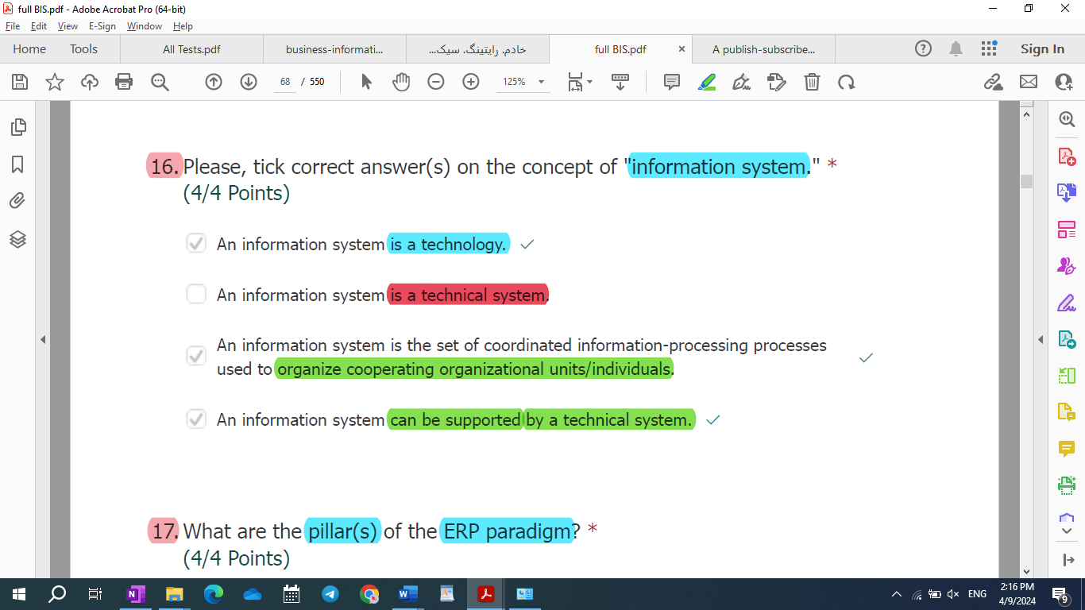

54) Please, tick the correct definition(s) of “delegation” according to agency

theory.

1. Delegation represents a continuous learning process that allows employees to be promoted to higher job positions in the hierarchy.

**2. Delegation represents an organizational must to make vertical information systems more efficient when environmental uncertainty is too high.**

3. Delegation represents a task with which a responsibility higher in the hierarchy enables another responsibility lower in the hierarchy to execute a set of production activities.

**4. Delegation represents a task with which a responsibility higher in the hierarchy enables another responsibility lower in the hierarchy to make decisions on a set of interrelated activities.**

Why is the market system more suitable than the hierarchical system to

cope with behavioral uncertainty?

**1. Because in a pure market system, individuals produce for themselves and, therefore, their objectives coincide with their organizational objectives as entrepreneurs.**

2. Because in a market system, individuals are not subject to hierarchical control.

3. Because in a market system, organizations can resort to "buy" solutions in make or buy decision processes.

4. **Because the coincidence between individual and organizational objectives in a pure market system makes individuals more willing towork and achieve their goals as entrepreneurs.**

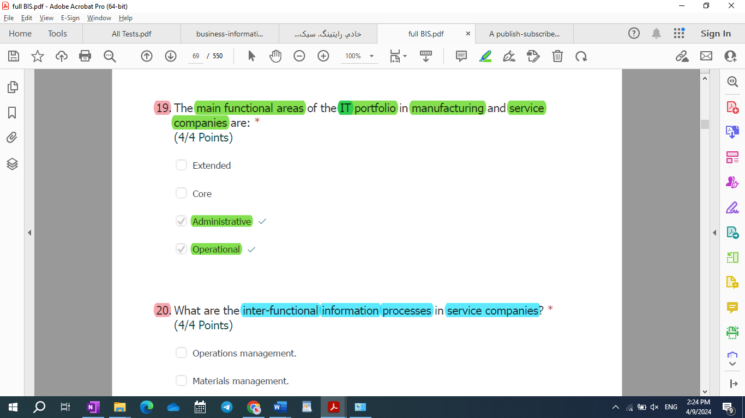

Executive portfolio not extended portfolio

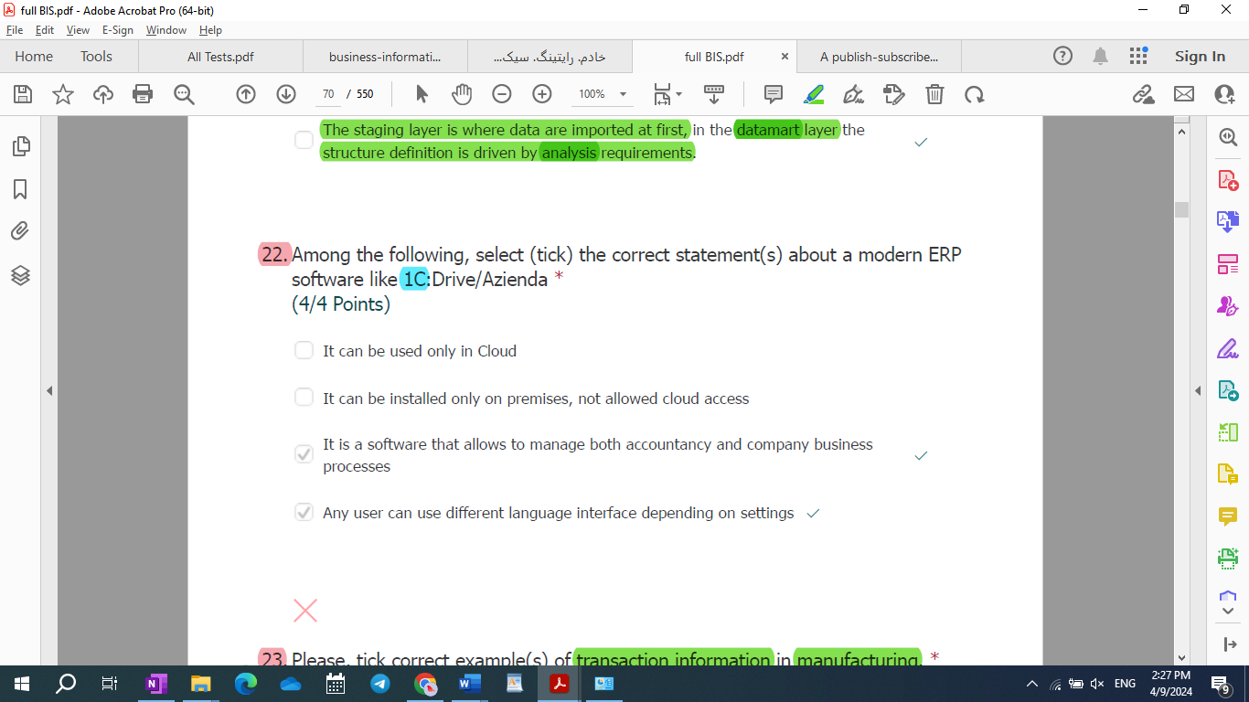

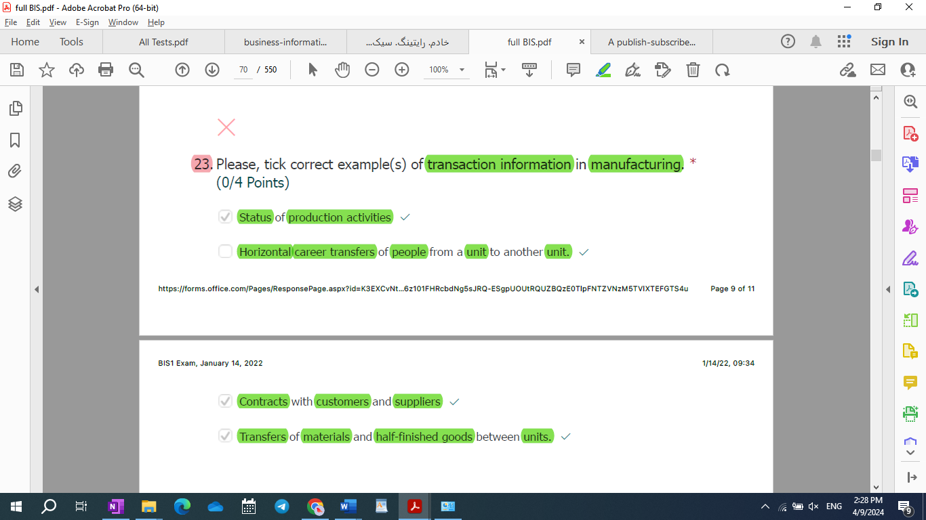

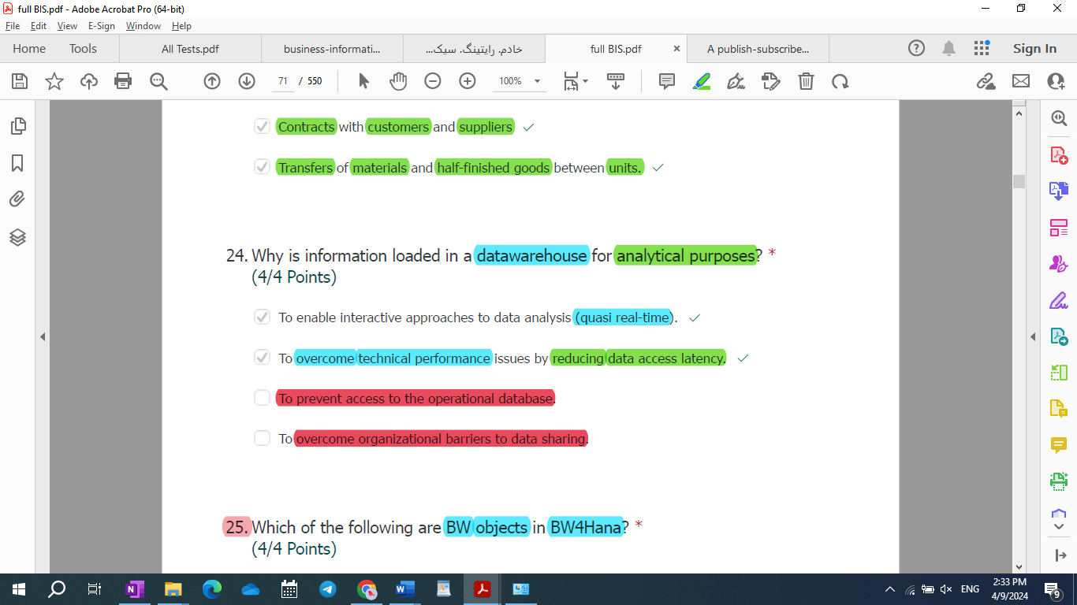

What are typical dimension(s) of an indicator in an executive information system? *

(4/4 Points)

20.

Stocks

Managers

Customers

Processes

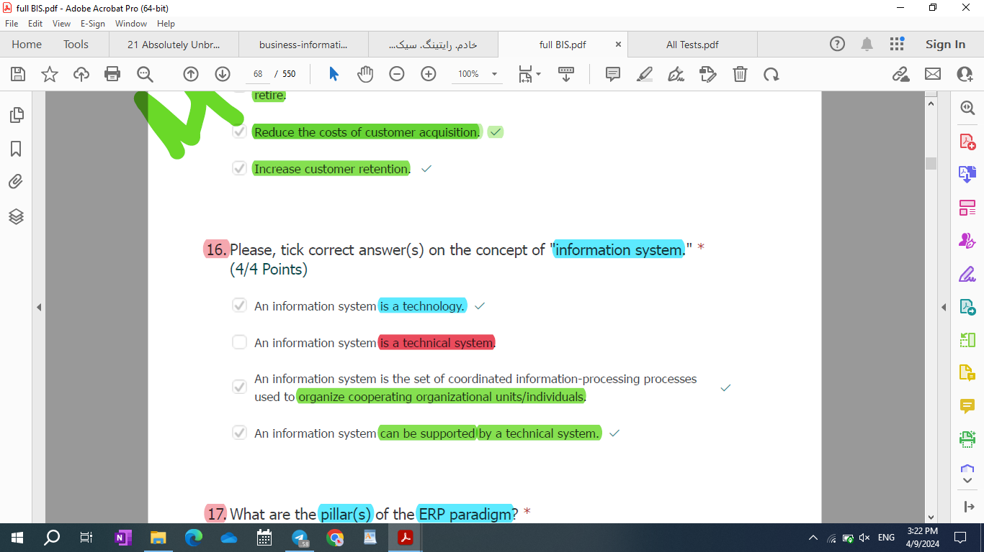

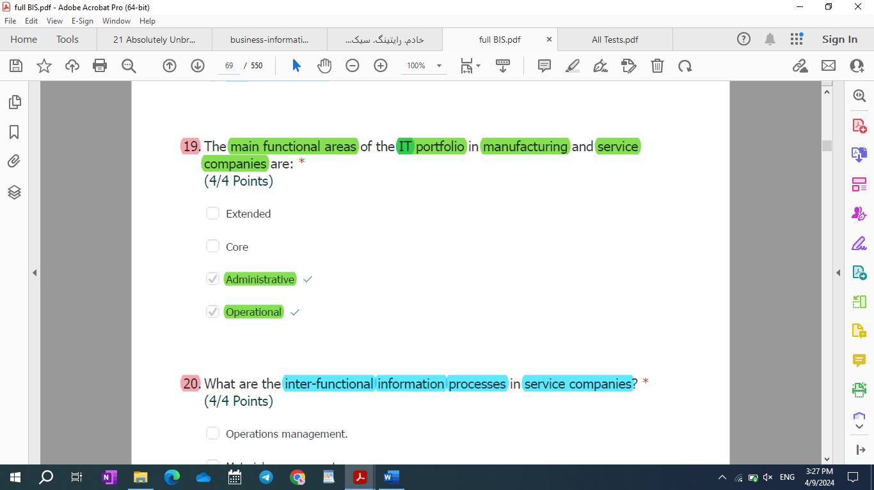

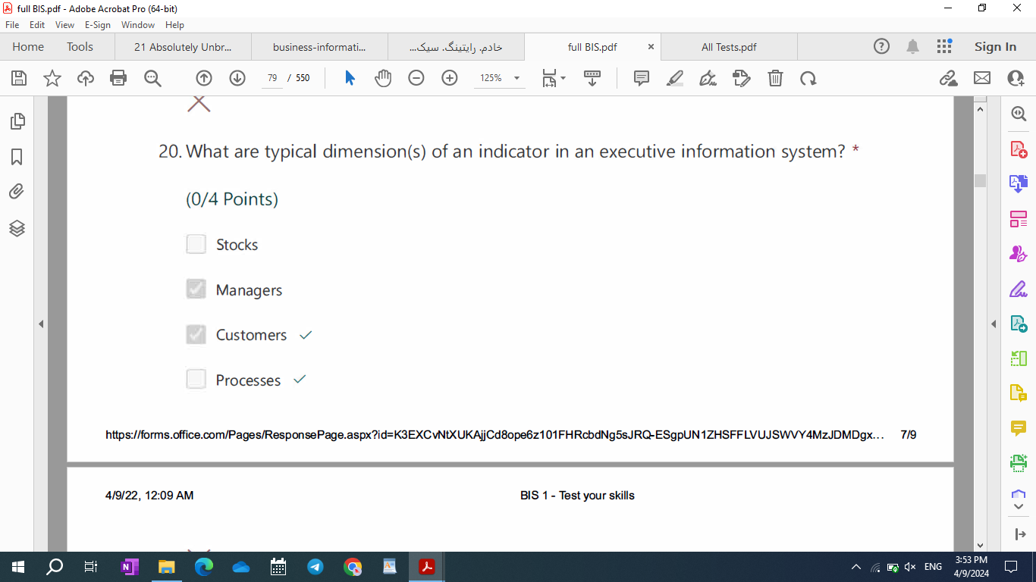

R-M: Repeated Which of the following are BW objects in BW4Hana? (4/4 Points)

* 1. Infoobjects
  2. ADSO
  3. Infocube
  4. Composite Providers

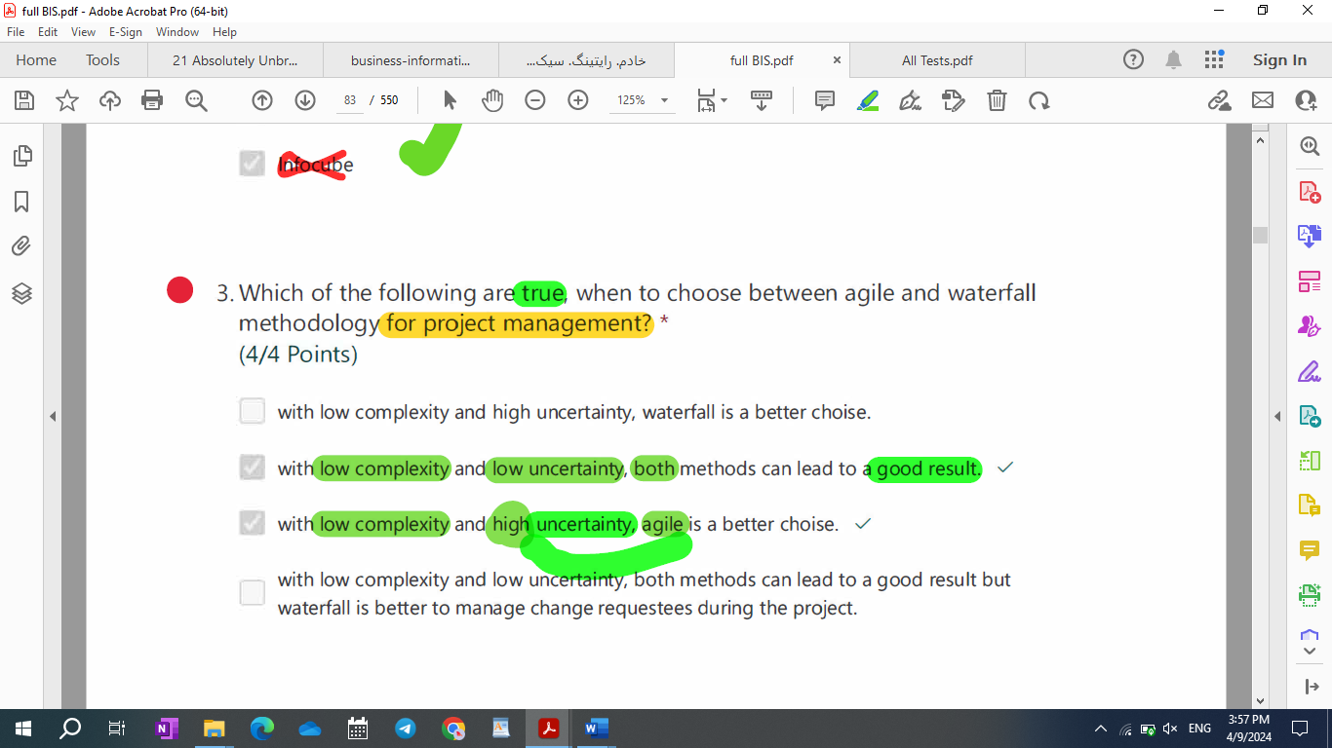

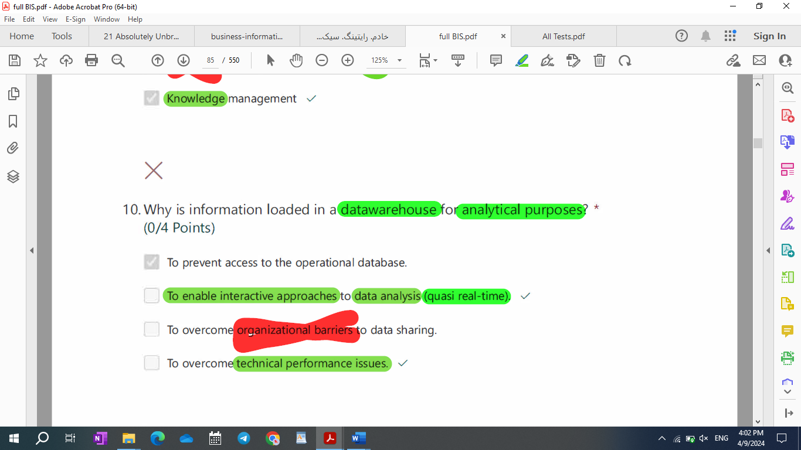

|  |
| --- |
| Examples of transaction information and catalog information |
| * 1. Contract withcustomers and suppliers   2. Status of produstion activities   3. Transfers of materials and half-finished goods between responsibilities   4. Horizontal career transfers of people from a unit to another unit.   5. Example: contract, start and end time of production activity  1. Certification of competences 2. Bank statements. 3. Product structure |

|  |
| --- |
| DWH |
| Why is executive information stored in the data warehouse?  To summarize information for the calculation of KPIs.  **To increase time performance in interactive processing.**  To support geographically distributed teams.  **To avoid excessive load on the operational database.**  8) Why is executive information stored in a datawarehouse?  1. Because a datawarehouse can be supported by cloud services  2. Because the datawarehouse can be supported by modern bid data technologies  3. **Because a datawarehouse stores pre-processed information that can be queried in real time**  4. Because the datawarehouse replacethe operational database  **Why is executive information stored in the DWH?**  **Because analytics are computationally complex and cannot access the operational database directly. Because the DWH stores aggregate information that can be handled more efficiently in interactive applications. ** |

|  |  |
| --- | --- |
| Production environment | Final users have access and can see data with no development ongoing |
| Development environment | Be able to make new developments with no impacts on the production environment |
| Quality environment | Objects are transported to the quality environment before the release in the production environment. The purpose is to test the release and the objects before transporting in the production environment. |

Please, select correct statements on Knowledge management?

1. **Knowledge management requires the design of new procedures to **use knowledge to obtain greater service customization**.**
2. **knowledge management **manages the new information on customeres** acquired during service produciton and distribution by transforming into knowledge.**
3. knowledge management **replaces** materials management in the vrsion of \*\***Porter’s**\*\* value chain adjusted for the service industry.
4. **knowledge management is a continuous **learning process**.**

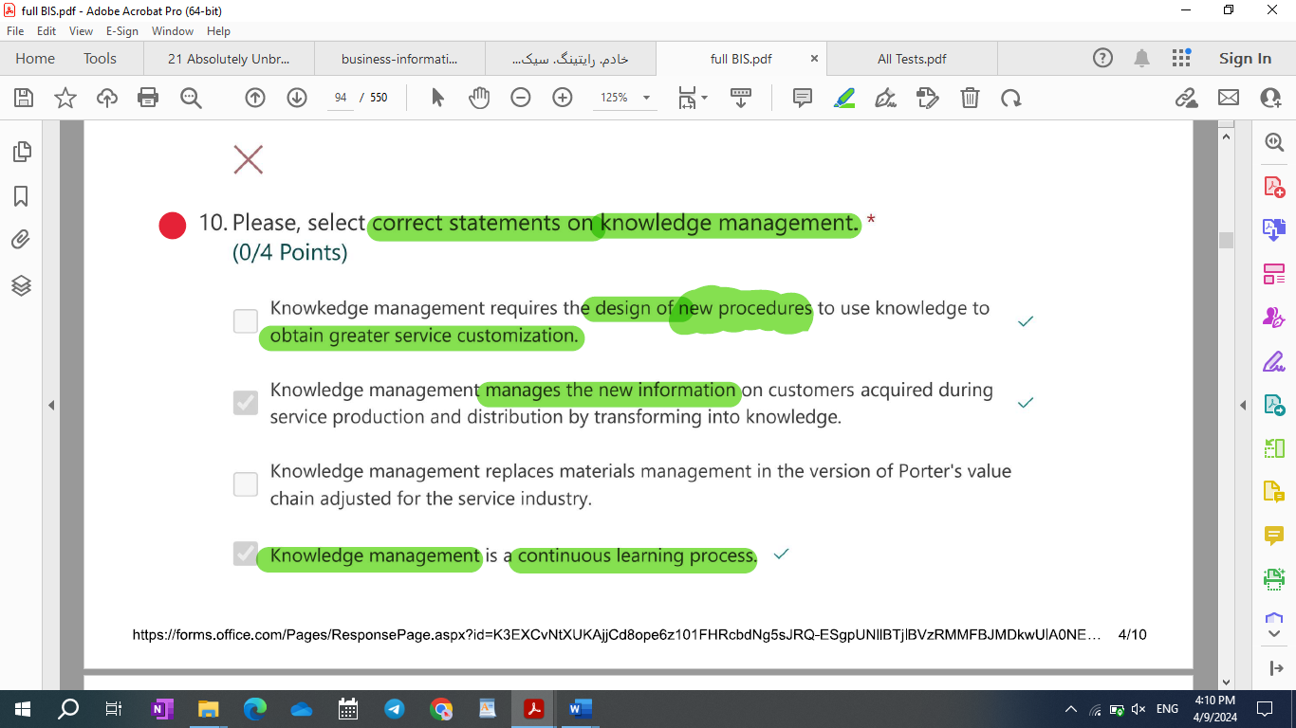

The most expensive distribution channel among the following:

1. Sales force
2. Web
3. Agency/shop
4. Cantact center

**What type of catalog information is crucial in MRP?**

Product structure

**What is the "bill of materials"?**

It is the **list of all the raw** materials, resources, and components (and the quantities of each of them) that are required **to manufacture a product**.

What are obstacle(s) to IT integration in service companies?

* [x] The learning process involved by knowledge management.
* [ ] The breadth of the service industry in terms of sub-industries.
* [ ] The lack of automation technologies.
* [ ] The skill shortage.

What is a KPI?

[ ] It is stored in the DWH.

[x] It is aggregate information providing a summary evaluation of a set of production activities or performance parameters.

[ ] It represents an organizational asset.

[x] It is a piece of executive information.

|  |  |  |
| --- | --- | --- |
| Post settlement phase and economic transaction | Input: exceptions | Output: exception management procedure |
| Negotiation phase and economic transactions | Input: set of suppliers | Output: one supplier and new requirement (both specified a contract (SLAs)) |
| Execution phase and economic transaction | Input: Contract | Output: Product/Service and expectations with respect to SLAs |
| Match-making phase and economic transaction | Input: requirement | Output: set of candidate suppliers that satisfy initial requirements |

Please, select correct statements on “mining”.

(0/4 Points)

1. Mining is performed with statistical techniques only.
2. Mining is part of analytical CRM,
3. Data science is the modern term that has replaced mining.
4. Mining refers to data analysis with the goal of discovering insights that are relevant for business management.

Mining 🡪 **part of analytical CRM**, **data science is the new name for it**, **data analysis to discover insight.**

|  |
| --- |
| phases of a CRISP-DM Process |
| Which of the following are phases of a CRISP-DM Process (Cross- Industry Standard Process for Data Mining)?   1. Data Modeling 2. AMS 3. Application Maintenance 4. Buiness Understanding   R-M: Which of the following are phases of a CRISP-DM Process (Cross-Industry Standard Process for Data Mining)?   1. Business Understanding 2. Data Modeling 3. Evaluation 4. Application Maintenance |

|  |
| --- |
| Role played by PCs in BPR |
| What is the role played by PCs in BPR (service companies)?   1. PCs are used to collect information that is then stored in the operational database in a structured format. 2. PCs are used to collect information on knowledge workers and calculate their incentives in real time. 3. PC are used to execute desktop applications embedding service procedures. 4. PCs store all the information regarding the customers served by the agency where the PC is located.   What is the role played by PCs in BPR (business process reengineering)?   * 1. PCs provide enough flexibility to support knowledge work and related decision making activities.   2. PCs represent a production technology.   3. PCs **do not automate** knowledge work, but can support it, making it easier.   4. PCs can be integrated with CIM and MRP. * 13-R-M: What is the role played by PCs in BPR (business process reengineering)?  1. PCs can be integrated with CIM and MRP. 2. PCs represent a production technology 3. PCs provide enough flexibility to support knowledge work and related decision-making activities. 4. PCs **automate** knowledge work |

|  |
| --- |
| Role played by IT |
| What is the role played by IT in the service industry?   1. Distribution technology. 2. Management technology. 3. Production technology. 4. Support to optimization of production resources. |

What is the relationship between environmental uncertainty and information processing capacity? *

* 1. Environmental uncertainty causes an increase in organizational information processing capacity.
  2. Environmental uncertainty **can be managed by increasing** an organization’s ability to process information (or information processing capacity).
  3. Environmental uncertainty **increases an organization’s requirements** for information processing capacity,
  4. Environmental uncertainty increases the requirements for information processing capacity up to the limits of bounded rationality.

**What is the relationship between bounded rationality and information processing capacity?**

Bounded rationality limits the ability of individuals to process information. Bounded rationality involves cooperation and coordination for organizations to reach beyond the limits of individual information processing capacity.

**What is the relationship between ERPs and ABC (activity-based costing)? (x2)**

ERPs enable ABC.

21) Why are market systems based on trust?

a) Because the parties in market transactions have long-lasting business relationships

b) Because the parties in market transactions have an unconscious trust in the ability of a market system to lead to a good quality-to-price ration through the competition mechanisms

c) Because the parties in market transactions have no control on each other’s production processes

d) Because it is difficult for a buyer to assess the actual quality of products.

23) Please, tick the correct statement(s) on the dimension of the indicators (i.e. executive information).

a) A fundamental dimension is **time**. Time is defined in terms of extension and granularity

b) A fundamental dimension is **products**, defined as the **main industry where the company operates**

c) A fundamental dimension is **responsibility**, defined as the organizational unit which the indicator refers to

d) A fundamental dimension is **clients**, defined as the market segment which the indicator refers to

14-R-M: What are correct statements on the dimension(s) of indicators in executive information systems?

1. Typical dimensions are time, customers and products.
2. Dimensions represent the units of measurement of KPIs.
3. Dimensions represent columns in the DWH tables
4. The value of an indicator is defined given a vector of values of relevant dimensions.

* The cost of the call center is a function of: *

Target level of service (waiting time and effectiveness in problem solving).

Team efficiency.

Number of calls in the time unit.

Degree of integration of the technology platform.

|  |
| --- |
| Customer segmentation |
| Customer segmentation can be performed with different approaches:  1- Value  2- Lifestyle  3- Loyalty  4- Market  Customer segmentation can be performed with different approaches: *   * 1. Targeting   2. Price sensitivity   3. Loyalty   4. Lifestyle   **Customer segmentation can be performed with different approaches:**  Price sensitivity – Loyalty - Lifestyle  **Customer segmentation can be performed with different approaches: (x2)**  Loyalty, when transactions can be associated with customers (for example with loyalty cards). Lifestyle Price sensitivity |

* Multi-channel integration in CRM ensures:

[x] Cross-channel service consistency.

[x] Value extraction from customer data with analytic CRM.

[x] Customer understanding and monitoring with executive functionalities.

[ ] Cross-channel information integration.

What are technical components of call centers?

[x] IVR

[x] Server machines

[] CSR

[x] Personal computers of call center operators

32 - What is the difference between BoM (Bill of Materials) and BoO (Bill of Operation)? M

- Y - BoM is not detailing how to manufacture but only what to manufacture.

- Y - BoO is always created after the BoM is defined.

- BoM is always created after the BoO is defined.

- There is no difference, these are acronyms of the same concept.

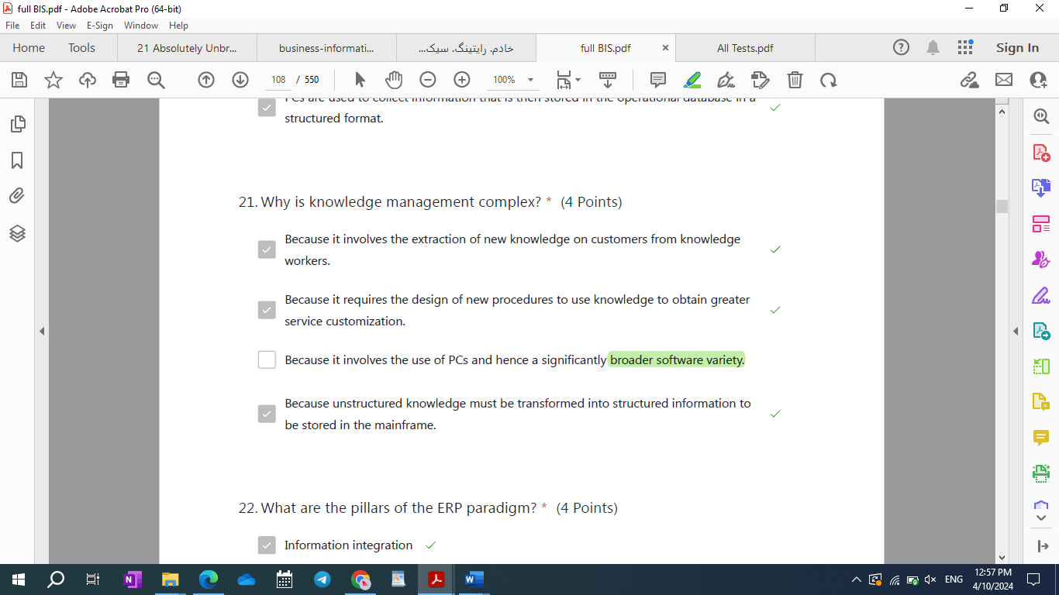

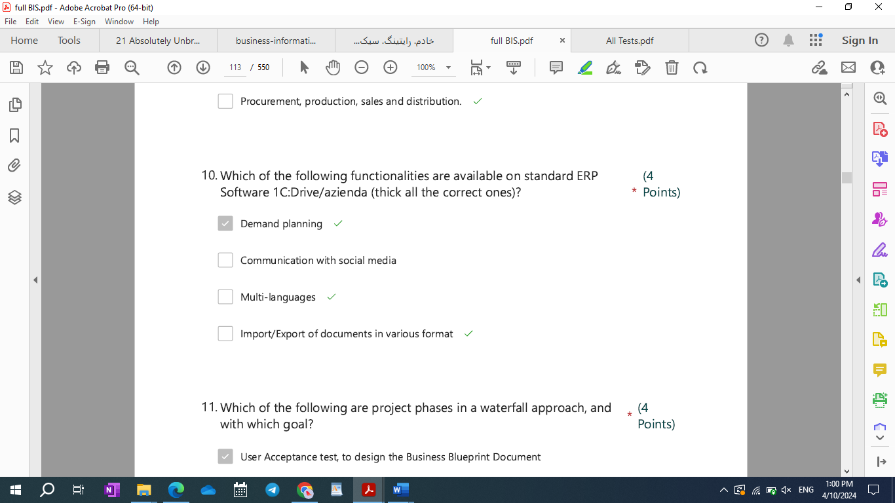

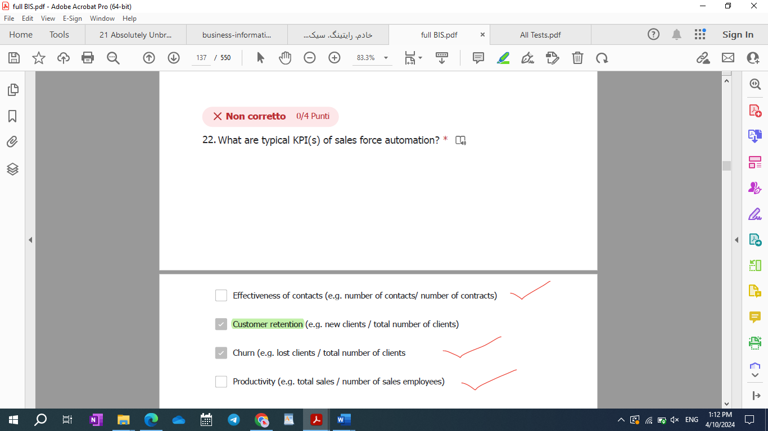

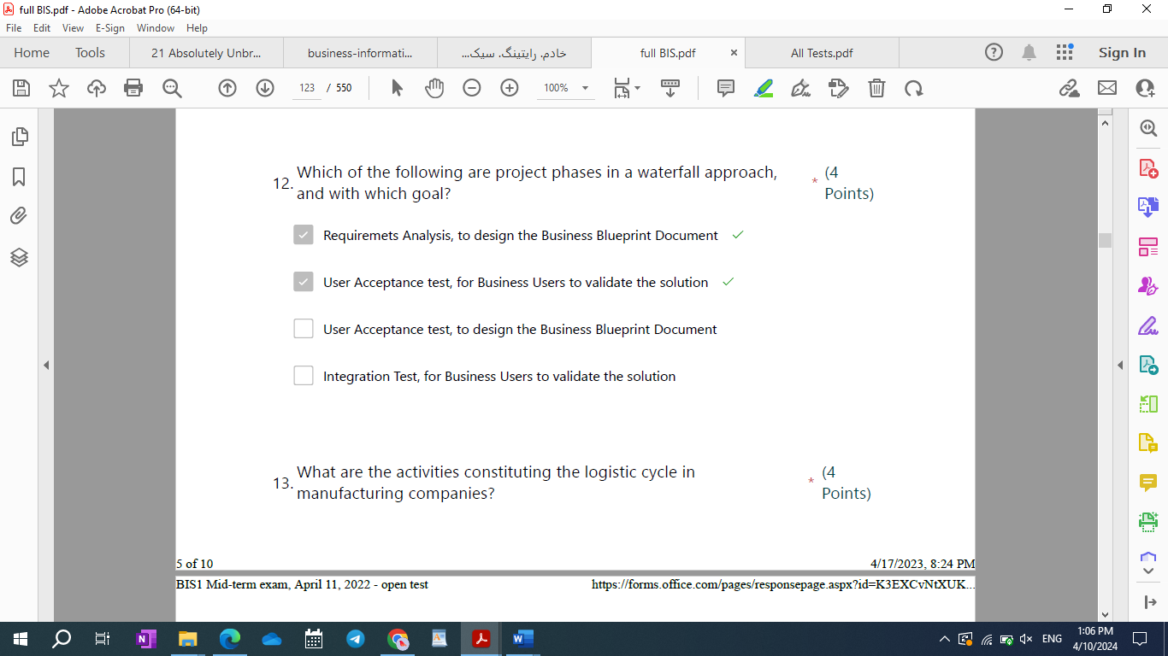

Az 139 mand

2024 test

* + 1. What are typical units in a project team?
  1. Project management
  2. Functional and technical team
  3. Board of directors
  4. Steering committee
     1. Why do companies have multiple operational databases instead of one integrated database?
     2. Companies have multiple operational databases when they do not have a fully integrated information system.
     3. Companies have multiple operational databases to make information management more efficient (divide et impera).
     4. Companies have multiple operational databases to comply with the ERP paradigm.
     5. Companies have multiple operational databases when they have heterogeneous data.
     6. What are data types in a cloud adoption project?

1. Structured and analytical.
2. Intemal and external.
3. Relational and non-relational (or multimedia).
4. Structured, unstructured, semi-structured and analytical.  
   * 1. What are recognized limitations of the waterfall model?
5. Inability to discover problems during implementation
6. Need for constant analysis
7. Difficulty in estimating time and cost for each phase.
8. Difficulty to implement changes when requirements change.  
   * 1. Please, tick statement(s) that correctly apply to CRM.
9. CRM is a component of a company’s Web site.
10. CRM realized multi-channel integration to guarantee consistent customer experience.
11. CRM includes SCM functionalities.
12. CRM is based on integrated customer data and includes dedicated executive (BI) functionalities.
13. What are “visualization engines” or “dashboards”?
    1. Front end modules of executive information systems.
    2. Any representation of administrative information.
    3. Engines that support graphical visualizations of data science results.
    4. Tools providing a visual representation of the information stored in the DW.
14. What are correct KPIs of the efficiency and effectiveness of physical distribution channels?
    1. Contracts/opportunities.
    2. Customer life time value.
    3. Contracts/contacts.
    4. Sales/number of sales people.
15. Please tick correct statements on transaction costs.
    1. According to transaction theory, transaction costs correspond to coordination costs in hierarchical coordination systems.
    2. Transaction costs are low in perfect market conditions.
    3. Transaction costs represent the costs emerging from the delegation of operational tasks.
    4. Transaction costs are the cost of execution of an economic transaction.
16. The automation of the operational processes is seen as a process of horizontal and vertical IT integration. Why?
    1. Because historically IT is implemented separately for separate “functions” without the concept of “process”.
    2. Because historically IT did not include key technologies enabling integration (e.g. networks, PCs, Web, etc.).
    3. Because of the difficulties in coordinating large groups of developers.
    4. Because of the limited economic benefits of integration.
17. How do executives express their information requirements?
    1. By selecting the most appropriate ERP.
    2. By specifying the schema of operational information that is key to decision making.
    3. By identifying key performance indicators to be calculated based on all operational data.
    4. By identifying key performance indicators to be calculated based on financial data only.
18. In a global sell out project…?
    1. Information must be integrated from external sources (e.g. IRI).
    2. Focus is on the integration of how much is sold by the manufacturer to retailers.
    3. Focus is on the integration of how much is sold by retailers to the end customers.
    4. Information is available internally from CRM.
19. Technical innovation increases the complexity of managerial work. Is this statement true?
    1. Yes, but limited to IT technical systems
    2. Yes
    3. No
    4. Yes but limited to non-IT technical systems.
20. Is the Operational Portfolio stand-alone?
    1. No ABC is an example of integration with the administrative portfolio.
    2. Yes in services, no in manufacturing.
    3. Yes, it represents a core implementation of IT in organizations and is typically stand alone.
    4. No, it is typically integrated with the other portfolios (executive and administrative), particularly with ERPs.
21. What is the correct definition of testing in an IT project?
    1. A Testing is the process of checking the final product to ensure that it meets requirements and expectations under operating conditions.
    2. Testing is a process ensuring that a software program responds correctly to all kinds of inputs.
    3. Testing is a process ensuring that different micro services interact with each other as expected.
    4. Testing is a process executing system functions through a series of predefined steps embedded in testing software.
22. What are correct components of the technology architecture of executive information systems?
    1. Data marts.
    2. Data lake.
    3. Datawarehouse.
    4. ETL
23. What happens if a CRM campaign does not meet its objectives?
    1. It could be stopped.
    2. It could be merged with other campaigns.
    3. It could be replanned.
    4. Channel mix may be modified.
24. Which are the main sections (modules) of  1C:Drive/Azienda program?
    1. CRM, Sales, Purchase, Warehouse, Production, Quality, Service, Accounting
    2. Sales, Purchase, Quality, Reporting, Research, Development, Q&A
    3. CRM, Accountancy, Human Resources, Sales, Purchase, Socials, Production, Marketing
    4. Sales, Purchase, Control, Budgeting, Forecast, Banking, Mobile
25. What are correct statements on “management orientation” towards IT?
    1. It is tightly related to the computer literacy of managers.
    2. It represents a dimension of Porter’s information intensity.
    3. It represents the degree to which managers view ILT as a strategic lever for their organization
    4. It represents a dimension of Porter’s model together with information intensity and IT intensity.
26. Why is IT called a “coordination technology”? *
    1. Because IT processes information and information is a typical input of managerial/coordination processes.
    2. Because IT is used to implement new work procedures and, therefore, changes coordination processes.
    3. Because IT is generally more complex than traditional non-IT technologies and cannot be assumed to have a tangible impact with operational KPIs.
    4. Because IT supports managerial/coordination processes in addition to operational processes.
27. Please, tick correct functionalities of sales force automation module of ERP.
    1. Management of client contact information.
    2. Customer analytics and dashboard.
    3. Management of information on key roles in the organizational structure of client companies.
    4. Offer and order configuration.
28. Please, tick correct statements on information processes in service companies.
    1. Knowledge management and order management are the information processes of service companies.
    2. Knowledge management replaces materials management in manufacturing.
    3. Order management manages the information regarding orders from order check in to post-sale services.
    4. Knowledge management manages the information regarding orders from order check in to post-sale services.
29. Please, tick correct statement(s) on operational information.
    1. Operational information has greater value in services compared to manufacturing.
    2. Some companies (e.g. Amazon, supermarkets) sell their operational information.
    3. Operational information is an organizational asset.
    4. The quality of operational information is a determinant of the quality of a company’s information system.
30. Please, tick correct statements on data warehouses.
    1. Information load in data warehouses is periodical (e.g. daily).
    2. Data warehouses store raw data, data marts store indicators.
    3. Information in data warehouses is periodically copied in the operational databases.
    4. Data warehouses and data marts can have different schemas.
31. What are functionalities belonging to the administrative porfolio?
    1. Invoicing.
    2. Preparation of the balance sheet.
    3. Operational planning.
    4. Human resources.
32. Please, tick correct statements on the pillars of the ERP paradigm.
    1. The operational and executive portfolios should be integrated to complete the horizontal and vertical integration process.
    2. ERPS should be modular to enable the gradual replacement of legacy systems.
    3. ERPS should include all fundamental functionalities supporting a company’s processes.
    4. ERPs should be used to set operational KPIs and measure performance accordingly.

2023 Jun-20

* 1. Why is knowledge management so critical in service companies?
     1. Because it is key to service customization.
     2. Because it is key to keep customer satisfaction constantly high.
     3. Because it helps transorm unstructured information on customers into structured information that can be easily analyzed with IT.
     4. Because it represents a continuous learning process needed to adapt to environmental uncertainty.
  2. Please, tick correct statement(s) on the product structure.
     1. It is a type of catalogue information.
     2. It is heavily used in computer integrated manufacturing.
     3. It is a type of operations planning information.
     4. It stores the structure of products with their components and quantities needed to produce each product item.
  3. Development environment
  4. What are functionalities belonging to extended ERP? *  
     Computer integrated manufacturing.  
     Balanced scorecard and dashboards.  
     Web site and CRM.  
     Supply chain management.
  5. What are business advantages from sales force automation? *  
     The sales force can be more easily replaced, limiting the risk of losing clients.  
     General sales governance is improved.  
     Sales force members can more easily cooperate with each other.  
     The sales capabilities can be made stronger.
  6. What are typical sales and distribution activities in manufacturing? *
     1. Order management
     2. Procurement
     3. Post sale processes
     4. External logistic
  7. Documents are managed on standard ERP software.
  8. Which of the following functionalities are available on a standard ERP Software like  :Drive/Azienda? *
     1. Management of production orders
     2. Multi-language interface
     3. Posting to social media
     4. Content management for a company’s Web site
  9. An information system is a technology?
     1. No, it is an organizational technology.
     2. Yes, but only in organizations that recognize IT as an organizational technology.
     3. No, it is a technical system.
     4. Yes.

1. Please, tick statement(s) that correctly apply to Activity Based Costing (ABC).
   * 1. According to ABC, operations are associated with costs
     2. According to ABC, operations have a price that can be used to control the expenses of different functions.
     3. ABC enables the assessment of progress from an operational management perspective (time, production rate, use of production plants/machines)
     4. With ABC, progress of operational activities can be shown on executive dashboards with more accurate financial indicators.
2. If operational information is not created in electronic format, it is lost, due to:
   1. The lack of storage capabilities in a format different from digital.
   2. The high costs of data entry.
   3. The high error rate of data entry.
   4. The limited economic benefits of information availability.
3. How is call center sizing performed?
   1. By monitoring the performance of call center operators and adjusting capacity on demand.
   2. By determining the ideal number of operators based on volumes of calls.
   3. By setting a target level of service in terms of waiting time.
   4. By setting a target service level in terms of effectiveness in solving customers’ issues.
4. What are the limitations of agency theory?
   1. It does not consider uncertainty due to the nature of tasks.
   2. It considers bounded rationality as a condition enabling market coordination in conditions of high uncertainty.
   3. It does not consider hierarchical coordination “inside” market transactions.
   4. It does not consider the impact of market uncertaintly on individual behaviour.
5. Is the Administrative Portfolio stand-alone? *
   1. Yes, it represents the first implementation of IT in organizations and is excluded by horizontal and vertical integration of the operational portfolio.
   2. No, activity based costing is an example of integration with the operational portfolio.
   3. No, it has been integrated by ERPs with the other portfolios.
   4. Yes in manufacturing, no in services.
6. What are correct statements on the dimension(s) of indicators in executive information systems?
   1. Typical dimensions are time, customers and products.
   2. Dimensions represent the metrics of KPIs.
   3. Dimensions represent columns in the DWH tables.
   4. Dimensions can be applied only if corresponding data marts are defined.
7. What are typical pitfalls of cloud adoption?
   1. Not having a cloud ERP.
   2. Vendor lock in.
   3. A need to operate legacy as well as new cloud systems.
   4. Not having the right skills in the IT function.
8. Why should organizational processes be redesigned to be “well managed” before IT implementation?
   1. To enable virtuous cycles, where processes continuously refine the information that they elaborate, with no information overload.
   2. To implement the right coordination procedures, either vertical or horizontal.
   3. To avoid vitious cycles, where IT decreases as opposed to increasing process performance.
   4. To rethink operational tasks and make the most efficient and effective use of IT.
9. What is the correct definition of testing in an IT project?
   1. Testing is a process ensuring that a software program responds correctly to all kinds of inputs.
   2. Testing is a process ensuring that different micro services interact with each other as expected.
   3. Testing is a process executing system functions through a series of predefined steps embedded in testing software.
   4. Testing is the process of checking the final product to ensure that it meets requirements and expectations under operating conditions.
10. What are phases of campaign management in CRM?
    1. Campaign evaluation.
    2. Campaign design.
    3. Reporting.
    4. Outbound calls.
11. Main sections(modules) of 1C:Drive
12. What are typical phases in a project value chain?
    1. Project management
    2. Project EIS
    3. Blueprint
    4. Go live
13. What are “visualization engines” or “dashboards”?
    1. Tools providing a visual representation of the KPIs stored in the DW.
    2. Engines that support graphical visualizations of quantitative information.
    3. Any representation of operational information.
    4. A front end functionality of executive information systems.
14. What are typical units in a project team?
    1. Project management
    2. Functional and technical team
    3. Board of directors
    4. Steering committee
15. What you can do with ERP software?
16. Why are personal computers a production technology?
    1. Because PCs have brought technology to an individual level
    2. Because they are used to automate and support knowledge work, especially in service companies.
    3. Because they are used to automate and support operations, especially in service companies.
    4. Because they are both procedural and flexible.

2022 January 31 – Double check them

1. **Please, tick the correct statement(s) on the organizational impact of IT** innovation.
   1. IT innovation increases individual specialization.
   2. innovation decreases individual specialization
   3. innovation increases organizational efficiency only.
   4. IT innovation increases organizational effectiveness only.
2. **What is the relationship between environmental uncertainty and information processing capacity?**
3. **How does transaction economics overcome the limits of decision theory?** 
   1. By considering market and hierarchical coordination as two ends of continuum.
   2. By considering organizations as open systems.
   3. By considering behavioural uncertainty in addition to environmental uncertainty.
   4. By recognizing the limitations of hierarchical systems.
4. **How does agency theory overcome the limits of transaction economics?**
   1. By recognizing that hierarchies can fail and can be replaced by market systems.
   2. By studying employment contracts as a special-purpose transaction.
   3. By recognizing that there exist market coordination mechanisms inside organizations.
   4. By recognizing that there exists a continuum between markets and hierarchies.
5. **Please, tick the correct definition of information intensity.**
6. **What are the activities constituting the logistic cycle in manufacturing companies?**
7. Please, tick correct statements on the horizontal and vertical integration of the IT portfolio.
   1. Horizontal integration is the integration of systems along operating processes.
   2. Horizontal integration is the integration of systems along primary and support processes.
   3. Vertical integration is the integration between the operational portfolio and the executive portfolio.
   4. Vertical integration is the integration between the administrative and executive portfolios.
8. Why is knowledge management complex? Greater?
9. How is greater complexity of the tasks of sales personnel managed in the BPR initiative of insurance companies?

[ ] It is managed with a higher degree of delegation.

[ ] It is managed by changing the incentive system of employees.

[x] It is managed by embedding service procedures in desktop applications.

[ ] It is managed by empowering employees.

1. What is executive information? It is a set of KPIs + aggregate…
2. Please, tick correct statements on ERPs.
   1. They have transformed the approach to computerization from coding to purchasing a package + consulting services.
   2. ERPs represent a global phenomenon.
   3. They integrate all three portfolios, administrative, operational and executive.
   4. They involve process prescriptiveness.

Please, tick correct statements on ERPs.

[ ] ERPs can be tailored to a company’s specific processes without coding…

[x] They integrate all three portfolios, administrative, operational and executive.

[ ] ERPs are software packages that can be easily personalized through parametrization.

[x] They have transformed the approach to computerization from coding to purchasing a package + consulting services.

[x] ERPs complete integration of operational and executive with the administrative portfolio.

[x] ERPs apply the principle of process prescriptiveness.

[ ] ERPs can be customized only through coding.

[ ] ERPs may or may not be parametrized, depending on organizational requirements.

[ ] ERP are comprehensive and typically address all cross-industry needs.

[x] There exist niche players focused on industry-specific functionalities.

[x] System integrators can combine sofware from different suppliers.

[x] No single ERP provider can offer all functionalities for all industries

1. What are the pillars of the ERP paradigm?
2. Multi-channel integration in CRM improves:
   1. Cross-channel service consistency.
   2. Value extraction from customer data with analytic CRM.
   3. Discovering insights that are relevant for coordination and efficient process management.
   4. Customer understanding and monitoring with executive functionalities.
3. Customer segmentation can be performed with different approaches:
4. What are technical components of call centers? * (4 punti)  
   Personal computers of call center operators.  
   CSR  
   Server machines  
   IVR
5. Which of the following companies can properly manage their business processes using software like 1C:Drive/azienda (thick all the correct ones)?
6. Which are the main sections (modules) of 1C:Drive/Azienda programs (select just one)?
7. What you can do with ERP Software 1C:Drive/Azienda (tick the correct ones)?
8. Select (just one) the most correct definition of a software like 1C:Drive/Azienda?
9. Which of the following functionalities are available on standard ERP Software 1C:Drive/azienda (tick all the correct ones)?
10. Which of the following statement(s) are **true**, when choosing between **agile** and **waterfall** methodology for project management?

In a company with two BW envirorments (development and production), what is the purpose of the development envirorment?

1. What is SAP ECC?
2. Which of the following are Business Intelligence purposes?
3. Which of the following is(are) a **false** statement(s) about **Cloud Computing**?

3. Among the following, select (tick) the correct example(s) of catalog information.

1 - Product catalog.

2 - Supplier directory.

3 - Invoices.

4 - Orders.

19 July 2023

1. What are recognized limitations of the waterfall model?
   * 1. Difficulty to implement changes when requirements change.
     2. Difficulty in estimating time and cost for each phase.
     3. Inability to discover problems during implementation
     4. Need for constant analysis
2. Which are the main sections (modules) of 1C:Drive/Azienda program?
3. What are “visualization engines” or “ dashboards”?
   1. Any representation of operational information
   2. Tools providing a visual representation of the information stored in the DW.
   3. Front end modules of executive information systems.
   4. Engines that support graphical visualizations of quantitative information.

4.Is the Administrative Portfolio stand-alone? *

* 1. Yes, it represents the first implementation of IT in organizations and is excluded by horizontal and vertical integration of the operational portfolio.
  2. No, activity based costing is an example of integration with the operational portfolio.
  3. No, it has been integrated by ERPs with the other portfolios.
  4. Yes in manufacturing, no in services.

5. How is call center sizing performed?

* 1. By monitoring the performance of call center operators and adjusting capacity on demand.
  2. By determining the ideal number of operators based on volumes of calls.
  3. By setting a target level of service in terms of waiting time.
  4. By setting a target service level in terms of effectiveness in solving customers’ issues.

1. What are correct examples of information shared by different production cycles in manufacturing?
   1. Information on orders is created during sales activities and used by production.
   2. Information on stocks is created by the materials management and used by order management during sale activities.
   3. Information on orders is created during sales activities and used by internal logistic.
   4. Information on production plans is created during sales activity and used by logistic processes.
2. What is the main difference between core and extended ERP?
   1. Core ERP is a set of functionalities supporting internal processes, while extended ERP is a set of functionalities supporting processes that interact with external actors (customers, suppliers…).
   2. Core ERP is a set of functionalities focusing on operations, while extended ERP focuses on management.
   3. Core ERP is a set of “must have” functionalities, while extended ERP is a set of “nice to have” functionalities.
   4. Core ERP is comprised of all functionalities developed before the year 2000, while extended ERP is comprised of all functionalities developed after the year 2000 .
3. What is the correct definition of testing in an IT project?
   1. A Testing is the process of checking the final product to ensure that it meets requirements and expectations under operating conditions.
   2. Testing is a process ensuring that a software program responds correctly to all kinds of inputs.
   3. Testing is a process ensuring that different micro services interact with each other as expected.
   4. Testing is a process executing system functions through a series of predefined steps embedded in testing software.
4. What are typical information sources used to populate the data warehouse?
   1. ERP operational data
   2. Indicators and KPIs from legacy systems
   3. Administrative information
   4. Operational information from legacy applications
5. Please, tick correct functionalities of sales force automation module of ERP.
   1. Management of client contact information.
   2. Customer analytics and dashboard.
   3. Management of information on key roles in the organizational structure of client companies.
   4. Offer and order configuration.
6. Why are the management processes of IT different from those of non-IT technologies?
   * + 1. Because IT is used to implement new coordinarion procedures, either vertical or horizontal.
       2. Because IT is generally more complex than traditional non-IT technologies and cannot be assumed to have a tangible impact with measurable KPIs.
       3. Because IT is an organizational technology that supports managerial/coordination processes in addition to operational processes.
       4. Because IT processes information and information is a resource different from tangible production resources and requires a specific management approach.
7. What are functionalities belonging to extended ERP?
   1. Materials requirements planning.
   2. Activity based costing
   3. Supply chain management.
   4. Company portal.
8. What happens if a CRM campaign does not meet its objectives?
   1. It could be replanned.
   2. Budget may be reduced.
   3. It could be stopped.
   4. Channel mix may be modified.
9. What are data types in a cloud adoption project?
   1. Structured, unstructured, semi-structured and analytical.
   2. Structured and analytical.
   3. Relational and non-relational (or multimedia).
   4. Internal and external.
10. If operational information is not created in electronic format, it is lost, due to:
    1. The lack of storage capabilities in a format different from digital.
    2. The high costs of data entry.
    3. The high error rate of data entry.
    4. The limited economic benefits of information availability.
11. What are agency costs?
    1. Agency costs represent the costs emerging from the delegation of operational tasks.
    2. Agency costs are the sum of decision costs and transaction costs of markets inside organizations.
    3. Agency costs represent the costs emerging from the delegation of decision-making tasks.
    4. Delegation is accompanied by internal contracts similar to market contracts and, thus, creates an internal market with additional coordination costs called agency costs.
12. What are correct KPIs of the efficiency and effectiveness of physical distribution channels?
    1. Customer life time value.
    2. Contracts/opportunities.
    3. Sales/number of sales people.
    4. Contracts/contacts.
13. what are the inter-functional information processes in service companies? KOS
14. Please, tick statement(s) that correctly apply to Activity Based Costing (ABC).
    1. According to , operational activities and resources are associated with costs
    2. According to , operational services have a price that can be used to control the expenses of different functions.
    3. ABC enables the assessment of progress from an operational management perspective (time, production rate, use of production plants/machines)
    4. With , progress of operational activities can be shown on executive dashboards that integrate administrative and operational information.
15. An information system is a technical system?
    1. No, it is an IT architecture.
    2. No.
    3. No, it is an organizational technology.
    4. Yes, but only in organizations that recognize IT as an organizational technology.
16. In a global sell out project…?
    1. Information must be integrated from external sources (e.g. IRI).
    2. Focus is on the integration of how much is sold by the manufacturer to retailers.
    3. Focus is on the integration of how much is sold by retailers to the end customers.
    4. Information is available internally from CRM.
17. What are typical units in a project team?
    1. Project management
    2. Functional and technical team
    3. Board of directors
    4. Steering committee
18. Please, tick components of the IT architecture of call centers.   
    Interactive voice response (IVR)  
    PC (client) of customer service representative (CSR).  
    CSR server.  
    Computer telephony integration (CTI)
19. What are correct components of the technology architecture of executive information systems?
    1. Data marts.
    2. Data lake.
    3. Datawarehouse.
    4. ETL
20. What are correct components of the tecnology architecture of executive information systems?
    1. Data marts.
    2. Data lake.
    3. Visualization engines.
    4. ETL
21. Please, tick correct statement(s) on the product structure.
    * 1. It is a type of catalogue information.
      2. It is heavily used in computer integrated manufacturing.
      3. It is a type of operations planning information.
      4. It stores the structure of products with their components and quantities needed to produce each product item.

2023 Jun 20

* 1. Why is knowledge management so critical in service companies?
     1. Because it is key to service customization.
     2. Because it is key to keep customer satisfaction constantly high.
     3. Because it helps transorm unstructured information on customers into structured information that can be easily analyzed with IT.
     4. Because it represents a continuous learning process needed to adapt to environmental uncertainty.
  2. Please, tick correct statement(s) on the product structure.
     1. It is a type of catalogue information.
     2. It is heavily used in computer integrated manufacturing.
     3. It is a type of operations planning information.
     4. It stores the structure of products with their components and quantities needed to produce each product item.
  3. Development environment
  4. What are functionalities belonging to extended ERP? *  
     Computer integrated manufacturing.  
     Balanced scorecard and dashboards.  
     Web site and CRM.  
     Supply chain management.
  5. What are business advantages from sales force automation? *  
     The sales force can be more easily replaced, limiting the risk of losing clients.  
     General sales governance is improved.  
     Sales force members can more easily cooperate with each other.  
     The sales capabilities can be made stronger.
  6. What are typical sales and distribution activities in manufacturing? *
     1. Order management
     2. Procurement
     3. Post sale processes
     4. External logistic
  7. Documents are managed on a standard ERP software.
  8. Which of the following functionalities are available on a standard ERP Software like 1C:Drive/Azienda?
     1. Management of production orders
     2. Multi-language interface
     3. Posting to social media
     4. Content management for a company’s Web site
  9. An information system is a technology?
     1. No, it is an organizational technology.
     2. Yes, but only in organizations that recognize IT as an organizational technology.
     3. No, it is a technical system.
     4. Yes.
  10. ABC
  11. If operational information is not created in electronic format, it is lost, due to:
      1. The lack of storage capabilities in a format different from digital.
      2. The high costs of data entry.
      3. The high error rate of data entry.
      4. The limited economic benefits of information availability.
  12. How is call center sizing performed?
      1. By monitoring the performance of call center operators and adjusting capacity on demand.
      2. By determining the ideal number of operators based on volumes of calls.
      3. By setting a target level of service in terms of waiting time.
      4. By setting a target service level in terms of effectiveness in solving customers’ issues.
  13. What are the limitations of agency theory?
      1. It does not consider uncertainty due to the nature of tasks.
      2. It considers bounded rationality as a condition enabling market coordination in conditions of high uncertainty.
      3. It does not consider hierarchical coordination “inside” market transactions.
      4. It does not consider the impact of market uncertaintly on individual behaviour.
  14. Is the Administrative Portfolio stand-alone? *
      1. Yes, it represents the first implementation of IT in organizations and is excluded by horizontal and vertical integration of the operational portfolio.
      2. No, activity based costing is an example of integration with the operational portfolio.
      3. No, it has been integrated by ERPs with the other portfolios.
      4. Yes in manufacturing, no in services.
  15. What are correct statements on the dimension(s) of indicators in executive information systems?
      1. Typical dimensions are time, customers and products.
      2. Dimensions represent the metrics of KPIs.
      3. Dimensions represent columns in the DWH tables.
      4. Dimensions can be applied only if corresponding data marts are defined.
  16. What are typical pitfalls of cloud adoption?
      1. Not having a cloud ERP.
      2. Vendor lock in.
      3. A need to operate legacy as well as new cloud systems.
      4. Not having the right skills in the IT function.
  17. Why should organizational processes be redesigned to be “well managed” before IT implementation? *
      1. To enable virtuous cycles, where processes continuously refine the information that they elaborate, with no information overload.
      2. To implement the right coordination procedures, either vertical or horizontal.
      3. To avoid vitious cycles, where IT decreases as opposed to increasing process performance.
      4. To rethink operational tasks and make the most efficient and effective use of IT.
  18. What is the correct definition of testing in an IT project?
      1. A Testing is the process of checking the final product to ensure that it meets requirements and expectations under operating conditions.
      2. Testing is a process ensuring that a software program responds correctly to all kinds of inputs.
      3. Testing is a process ensuring that different micro services interact with each other as expected.
      4. Testing is a process executing system functions through a series of predefined steps embedded in testing software.
  19. What are phases of campaign management in CRM?
      1. Campaign evaluation.
      2. Campaign design.
      3. Reporting.
      4. Outbound calls.
  20. Which are the main sections of ERP software?
  21. What are typical phases in a project value chain? *
      1. Project management
      2. Project EIS
      3. Blueprint
      4. Go live
  22. What are “visualization engines” or “dashboards”?
      1. Front end modules of executive information systems.
      2. Any representation of administrative information.
      3. Engines that support graphical visualizations of data science results.
      4. Tools providing a visual representation of the information stored in the DW.
  23. What are typical units in a project team?
      + 1. Project management
        2. Functional and technical team
        3. Board of directors
        4. Steering committee
  24. What you can do with ERP software?
  25. Why are personal computers a production technology?
      1. Because PCs have brought technology to an individual level
      2. Because they are used to automate and support knowledge work, especially in service companies.
      3. Because they are used to automate and support operations, especially in service companies.
      4. Because they are both procedural and flexible.

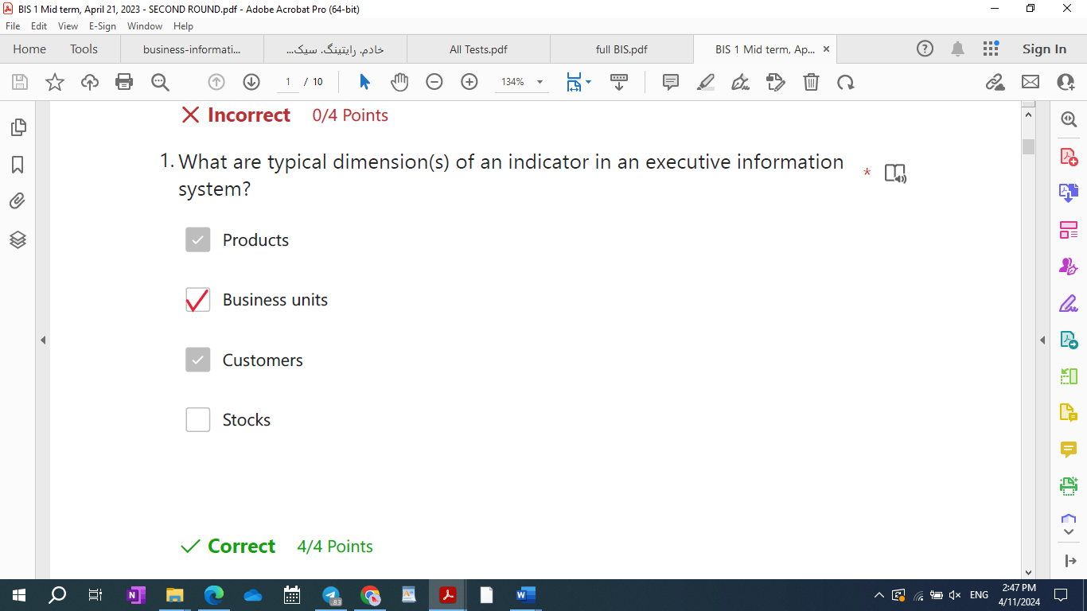

2023 September 1

1. Please, tick statement(s) that correctly apply to ERPs.
   1. ERPS are packages that are off-the-shelf and plug-and-play.
   2. ERPs are packages that can be customized through parametrization (no-coding).
   3. ERPS are custom developed software implementing core and extended functionalities.
   4. ERPs can be customized through ad hoc coding with a programming language (proprietary for large ERPS).
2. What is the correct definition of testing?
3. Please tick correct statements on transaction costs.
   1. Transaction costs are the cost of execution of an economic transaction.
   2. According to transaction theory, transaction costs correspond to coordination costs in hierarchical coordination systems.
   3. Transaction costs represent the costs emerging from the delegation of operational tasks.
   4. Transaction costs are low in perfect market conditions.
4. Why do companies have multiple operation datebases?
5. What happens if a CRM? 4 option is correct
6. Is the operational portfolio stand alone?
7. In a global sell out projects?
8. What are pillars of the ERP paradigm? *  
   Information integration.  
   ~~Information extension and modularity.~~  
   No or low coding.  
   Process prescriptiveness.
9. …it is lost, due…
10. Please, tick correct statements on the CRM vision.
    1. The CRM vision is implemented by three main modules: operational, campaign management, and executive CRM.
    2. The CRM vision is implemented by three main modules: operational, analytical, and executive CRM.
    3. The CRM vision takes the perspective of clients and aims at providing them with a consistent service across channels.
    4. The CRM vision is used to set service-level KPIs and measure performance accordingly.
11. Please, tick correct statement(s) on operational information.
    1. Operational information has greater value in services compared to manufacturing.
    2. Some companies (e.g. Amazon, supermarkets) sell their operational information.
    3. Operational information is an organizational asset.
    4. The quality of operational information is a determinant of the quality of a company’s information system.
12. Please, tick correct statements on data warehouses.
    1. Information load in data warehouses is periodical (e.g. daily).
    2. Data warehouses store raw data, data marts store indicators.
    3. Information in data warehouses is periodically copied in the operational databases.
    4. Data warehouses and data marts can have different schemas.
13. Data mart – visualization- ETL
14. Technical innovation increases individual specialization. Is this statement true?
    * 1. No
      2. Yes but limited to non-IT technical systems
      3. Yes
      4. Yes, but limited to IT technical systems
15. What are recognized limitations of the waterfall model?
    * 1. Inability to discover problems during implementation
      2. Need for constant analysis
      3. Difficulty in estimating time and cost for each phase.
      4. Difficulty to implement changes when requirements change.
16. Which are the main section of ERP software?
17. What are correct examples of information shared by different production cycles in manufacturing?
    1. Information on orders is created during sales activities and used by production.
    2. Information on stocks is created by the materials management and used by order management during sale activities.
    3. Information on orders is created during sales activities and used by internal logistic.
    4. Information on production plans is created during sales activity and used by logistic processes.
18. What are functionalities belonging to extended ERP?
    1. Materials requirements planning.
    2. Activity based costing
    3. Supply chain management.
    4. Company portal.
19. Visualization engines ?
20. Please, tick correct functionalities of sales force automation module of ERP.
    * 1. Management of client contact information.
      2. Customer analytics and dashboard.
      3. Management of information on key roles in the organizational structure of client companies.
      4. Offer and order configuration.
21. Cloud adaption projects
22. Why are the management processes of IT different from those of non-IT technologies?
    * + 1. Because IT is used to implement new coordinarion procedures, either vertical or horizontal.
        2. Because IT is generally more complex than traditional non-IT technologies and cannot be assumed to have a tangible impact with measurable KPIs.
        3. Because IT is an organizational technology that supports managerial/coordination processes in addition to operational processes.
        4. Because IT processes information and information is a resource different from tangible production resources and requires a specific management approach.
23. Project team
24. What are correct KPIs of the efficiency and effectiveness of physical distribution channels?
    1. Contracts/opportunities.
    2. Customer life time value.
    3. Contracts/contacts.
    4. Sales/number of sales people.
25. Please, tick correct statements on information processes in service companies.
    1. Knowledge management and order management are the information processes of service companies.
    2. Knowledge management replaces materials management in manufacturing.
    3. Order management manages the information regarding orders from order check in to post-sale services.
    4. Knowledge management manages the information regarding orders from order check in to post-sale services.
       * 1. tember 1 – 2
26. What happens if a CRM campaign does not meet its objectives?
    1. It could be replanned.
    2. Budget may be reduced.
    3. It could be stopped.
    4. Channel mix may be modified.
27. If operational information is not created in electronic format, it is lost, due to:
    1. The lack of storage capabilities in a format different from digital.
    2. The high costs of data entry.
    3. The high error rate of data entry.
    4. The limited economic benefits of information availability.
28. Please, tick correct functionalities of sales force automation module of ERP.
    1. Management of client contact information.
    2. Customer analytics and dashboard.
    3. Management of information on key roles in the organizational structure of client companies.
    4. Offer and order configuration.
29. Is operational portfolio stand alone?
30. Technical innovation increases the complexity of managerial work. Is this statement true?
    1. Yes, but limited to IT technical systems
    2. Yes
    3. No
    4. Yes but limited to non-IT technical systems.
31. Please, tick correct statements on data warehouses.
    1. Information load in data warehouses is periodical (e.g. daily).
    2. Data warehouses store raw data, data marts store indicators.
    3. Information in data warehouses is periodically copied in the operational databases.
    4. Data warehouses and data marts can have different schemas.
32. Please, tick statement(s) that correctly apply to ERPs.
    1. ERPS are packages that are off-the-shelf and plug-and-play.
    2. ERPs are packages that can be customized through parametrization (no-coding).
    3. ERPS are custom developed software implementing core and extended functionalities.
    4. ERPs can be customized through ad hoc coding with a programming language (proprietary for large ERPS).
34. What are recognized limitations of the waterfall model?
35. Inability to discover problems during implementation
36. Need for constant analysis
37. Difficulty in estimating time and cost for each phase.
38. Difficulty to implement changes when requirements change.
39. Why are the management processes of IT different from those of non-IT technologies?
    * + 1. Because IT is used to implement new coordinarion procedures, either vertical or horizontal.
        2. Because IT is generally more complex than traditional non-IT technologies and cannot be assumed to have a tangible impact with measurable KPIs.
        3. Because IT is an organizational technology that supports managerial/coordination processes in addition to operational processes.
        4. Because IT processes information and information is a resource different from tangible production resources and requires a specific management approach.
40. What are pillars of the ERP paradigm? *  
    1. Information integration.  
    ~~2. Information extension and modularity.~~  
    3. No or low coding.  
    4. Process prescriptiveness.
41. Please tick correct statements on transaction costs.
    1. According to transaction theory, transaction costs correspond to coordination costs in hierarchical coordination systems.
    2. Transaction costs are low in perfect market conditions.
    3. Transaction costs represent the costs emerging from the delegation of operational tasks.
    4. Transaction costs are the cost of execution of an economic transaction.
42. Please, tick correct statement(s) on operational information.
    1. Operational information has greater value in services compared to manufacturing.
    2. Some companies (e.g. Amazon, supermarkets) sell their operational information.
    3. Operational information is an organizational asset.
    4. The quality of operational information is a determinant of the quality of a company’s information system.
43. Data mart – visualization – ETL
44. Why do companies have multiple operational databases instead of one integrated database?

1. Companies have multiple operational databases when they do not have a fully integrated information system.

* + 1. Companies have multiple operational databases to make information management more efficient (divide et impera).
    2. Companies have multiple operational databases to comply with the ERP paradigm.
    3. Companies have multiple operational databases when they have heterogeneous data.

1. Cloud adoption projects
2. Definition of testing
3. Please, tick correct statements on information processes in service companies.
   1. Knowledge management and order management are the information processes of service companies.
   2. Knowledge management replaces materials management in manufacturing.
   3. Order management manages the information regarding orders from order check in to post-sale services.
   4. Knowledge management manages the information regarding orders from order check in to post-sale services.
4. What are correct examples of information shared by different production cycles in manufacturing?
   1. Information on orders is created during sales activities and used by production.
   2. Information on stocks is created by the materials management and used by order management during sale activities.
   3. Information on orders is created during sales activities and used by internal logistic.
   4. Information on production plans is created during sales activity and used by logistic processes.
5. Which are the main sections of 1C:Drive?
6. Visualization engines
7. What are functionalities belonging to extended ERP?
   1. Materials requirements planning.
   2. Activity based costing
   3. Supply chain management.
   4. Company portal.
8. Please, tick correct statements on the CRM vision.
   1. The CRM vision is implemented by three main modules: operational, campaign management, and executive CRM.
   2. The CRM vision is implemented by three main modules: operational, analytical, and executive CRM.
   3. The CRM vision takes the perspective of clients and aims at providing them with a consistent service across channels.
   4. The CRM vision is used to set service-level KPIs and measure performance accordingly.
9. What are correct KPIs of the efficiency and effectiveness of physical distribution channels?
   1. Contracts/opportunities.
   2. Customer life time value.
   3. Contracts/contacts.
   4. Sales/number of sales people.
10. Sell out project
11. Project team

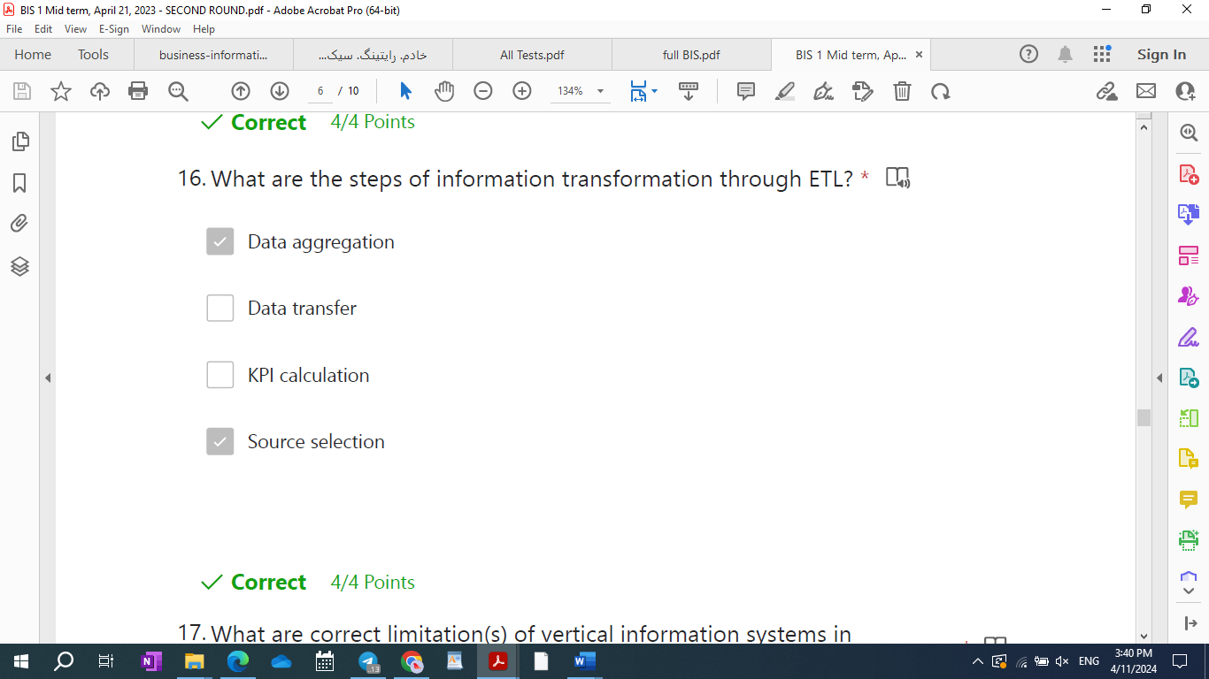

1. What are correct limitation(s) of vertical information systems in hierarchical coordination?
   1. Bounded rationality.
   2. Lack of coordination in case of churn.
   3. Lack of organizational flexibility
   4. Limited scalability to manage a growing number of exceptions
2. What is the meaning of information integration according to the ERP paradigm?
   1. Information should have the same quality across all organizational processes.
   2. Information can be stored in multiple databases but should have a common integrated conceptual and logical schema.
   3. All ERP functionalities should see the same value of all the fields in any table in the operational database at all times.
   4. All information should be stored in the same database.
3. How can companies deal with environmental uncertainty according to decision theory?
   1. Increase information processing capacity with horizontal information systems.
   2. Implement market coordination mechanisms.
   3. Increase information processing capacity with vertical information systems.
   4. Create independent divisions.
4. What is the so called “knowledge barrier” in BPR? *

1- It is the limited ability of knowledge workers to take on process responsibility and complexity of work.  
2- It is a barrier to the implementation of the enabling technologies of BPR in service companies.  
3- It represents a barrier that prevents knowledge workers to become less specialized.  
4- It is a barrier to process change due to the bounded rationality of knowledge workers.

1. Which of the following companies can properly manage their business processes using software like 1C:Drive/azienda?
   1. A company doing import and export
   2. Banks and financial institutions
   3. SMEs in the manufacturing industry
   4. Schools
2. What is a change data capture tool?  
   1- It is a typical tool used to update the operational DB.  
   2- It is a component of a cloud architecture for BI.  
   3- It is a software that is able to get (pull) the data updates from a database and replicate those changes in another target database.  
   4- It is a software tool that is used to guarantee data alignment across multiple databases.
3. What is an ERP? *  
   A production technology.  
   A custom software.  
   A coordination technology.  
   A software package.
4. Please, tick correct statement(s) on operational information. *   
   1- Operational information is created by both production and management processes.  
   2- Operational information is the information stored in the operational database and is created by operational processes.  
   3- Catalog information is a class of operational information, but is not stored in the operational database.  
   4- Transaction information is a class of operational information.
5. What are the limitations of the decision school?
   * 1. It ties uncertainty only to the environment (no internal sources of uncertainty are considered, such as the uncertainty caused by the opportunistic behaviour of employees).
     2. It considers hierarchies as the only coordination mechanism.
     3. It considers markets as an alternative to organizations.
     4. It considers bounded rationality as the only source of uncertainty
6. Is groupwork relevant in the design of non-IT technologies? Why?
   1. No, it is not relevant, since groupwork refers to interfunctional cooperation and coordination, which was not considered in traditional organization theory.
   2. Yes, it is relevant in terms of synchronization of logistic activities.
   3. No, it is not relevant, since focus wan on the production line where each individual has its own task.
   4. Yes, it is relevant, but only in manufacturing where production activities need to be coordinated through cooperation on production tasks.
7. What are correct statement(s) on service delivery? *
   1. Service delivery is the overlap between the production and distribution of services.
   2. Service delivery is composed by front-office and back-office tasks.
   3. Service delivery is a new term coined by Porter to indicate the fact that in service companies services are (partly) produced and delivered at the same time.
   4. Service delivery is a subset of a service company’s primary processes.

1. Key performance indicators
2. to pay back a debt by making small regular payments over a period of time
3. Key performance indicators
4. **You should write it at the end of multiple choice question when you are asking the question from chat GPT.**